Flipping your Class with Team-Based Learning

This paper will introduce you to the Team-Based Learning (TBL) framework and make a case for its applicability to any classroom where you want your students to learn how to apply the course concepts. Many students often have difficulty in moving from abstractions presented in readings and lectures to concrete problem solving in real-world situations. Many faculty become frustrated by some students inabilities to apply what they know to even slightly different situations or contexts then those explained in lectures or given in homework problems. TBL put students in situations where they need to apply the abstraction they have learned to concrete real-world situations and get immediate and targeted feedback on the quality of their thinking and the problem-solving process they used. TBL’s unique classroom protocols ensure that students routinely get targeted and specific feedback to guide the development of their thinking.

What is Team-Based Learning?

Team-Based Learning is a unique and powerful form of small group learning that was developed by Larry Michealsen at the University of Oklahoma Business School in the late 1970’s.

TBL provides a complete coherent framework for building a powerful flipped course experience. TBL enables you to realize the full potential of the flipped classroom by providing coherent organizational structures to design and deliver your course. TBL addresses the two major questions you need to ask when flipping any course.

“how can I ensure my students prepare for class?”

“when students are prepared, what am I going to do with the ‘free’ class time?”

TBL provides excellent answers to both these questions. First, it assures that students come to class prepared by employing TBL’s unique Readiness Assurance Process and second, uses TBL’s 4S Application Activities framework to have student teams analyze complex concrete situations, and identify a best course of action, then publically declare their decision in a way that fosters inter-team discourse and examination of each other’s problem-solving approaches.

An analogy might be help here, to help you understand the dynamic that we are trying to create in the TBL classroom.
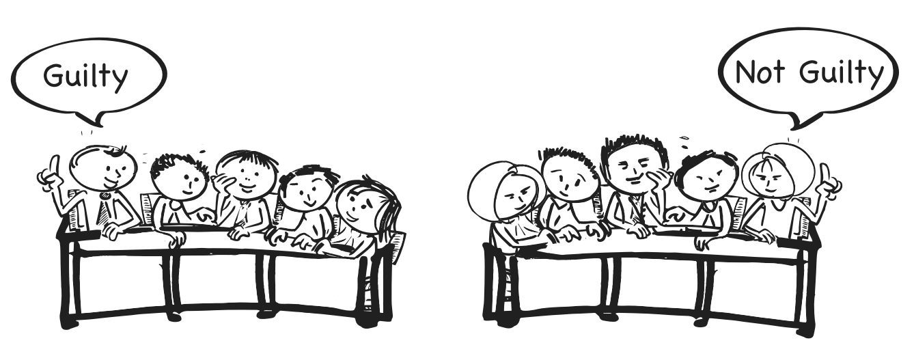
TBL is like a courtroom jury.

Think of a courtroom jury that is required to do a deep analysis by sifting through large amounts of evidence, testimony, statements, and transcripts to come up with a “simple” looking decision: guilty or not guilty.

Imagine yourself on a jury as the foreperson; you rise and state your jury’s verdict, but another foreperson rises from a different jury team in the same courtroom and states a different verdict. You naturally want to talk to them; you naturally want to ask “why?” This public declaration and the “simple” comparability between decisions naturally induces everyone to ask the question “why”.

This analysis, decision making, public reporting, and public discourse comprise the heart of the TBL experience. The WHY question provides the instructional fuel to power insightful debates between student teams and gives everyone immediate and focused feedback on the quality of their thinking they used to arrive at their decision.

Structure of a TBL Course

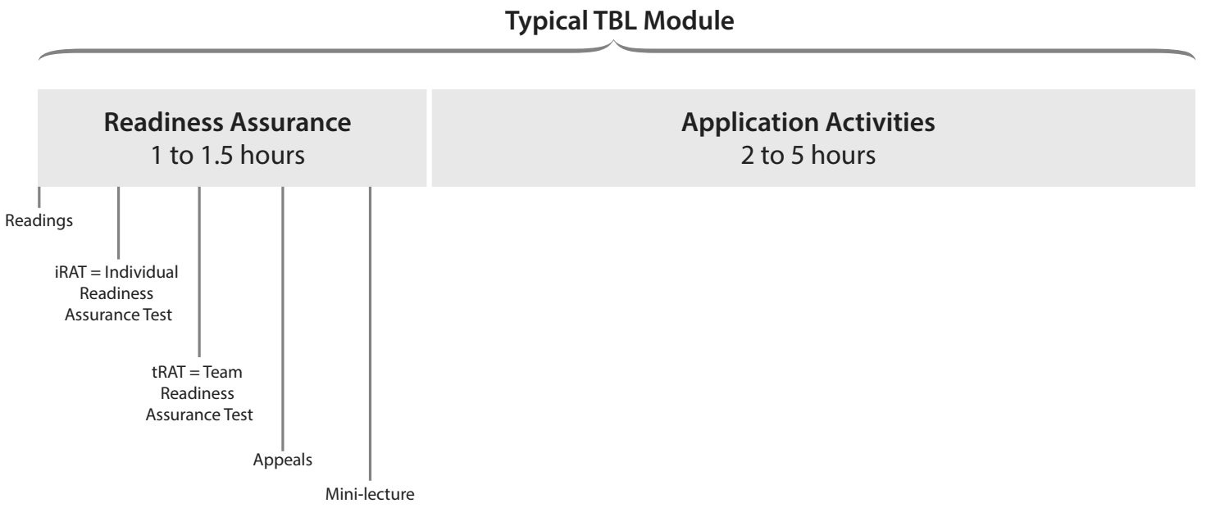

TBL courses have a recurring pattern of instruction that is typical of many flipped classrooms. Students prepare before class and then spend the bulk of class time solving problems. A typical TBL course is divided into five to seven modules. Each module has a similar rhythm, opening with the Readiness Assurance Process (more on this in next section) that prepares the students for the activities that follow, and then moving to 4S Application Activities (more on this later) that often grow in complexity and length as the module progresses. As the module is ending, you provide some closure and reinforcement. Module length varies in different contexts. As the next module begins, the familiar TBL rhythm starts to build: out-of-class preparation, the Readiness Assurance Process, followed by a series of Application Activities.

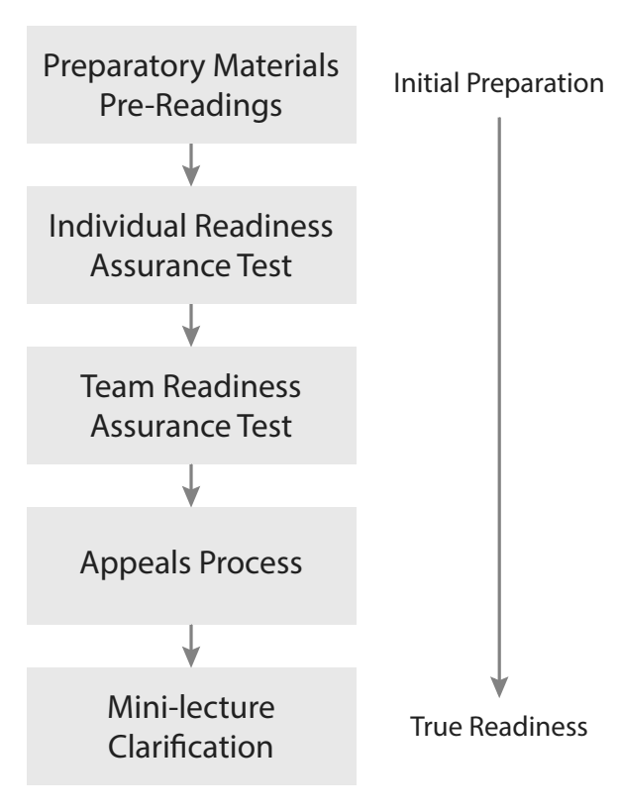
It’s the synergy between the crystal-clear objectives of the instructional sequence, the Readiness Assurance Process, and the Application Activities that follow that gives TBL much of its instructional power. TBL is more than the sum of its parts.

Two Major TBL Protocols

There are two protocols that are essential to TBL. They are the Readiness Assurance Process and the 4S Application Activity framework.

Protocol 1: Readiness Assurance Process (RAP)

The Readiness Assurance Process is designed to get your students ready for each modules activities. The RAP is a carefully scripted five-stage process that is used at the beginning of each module. The purpose of the RAP is to ensure that students understand the fundamental concepts, definitions, and foundational knowledge they need to begin the problem-solving conversation. The Readiness Assurance Process centers around administering two short multiple-choice tests, first the test is taken individually, and then the same test is retaken immediately by the student teams. It sounds simple, but it has powerful results.

Let’s start by examining each of the five stages of the Readiness Assurance Process.
Stage 1: Student Pre-class Preparation
Stage 2: Individual Readiness Assurance Test (iRAT)
Stage 3: Team Readiness Assurance Test (tRAT)
Stage 4: Appeals Process
Stage 5: Mini-Lecture/Clarification

Stage 1: Pre-Class Preparation

Prior to the beginning of each module, students are assigned readings or other preparatory materials such as newspaper articles, journal articles, textbook chapters, podcasts, PowerPoint slides, or instructional videos. They must study these materials to prepare for the RAP tests that in turn prepares them for the module activities. We typically assign 30-60 pages of reading in preparation for a two-week module. The specific amount of preparatory materials will depend on the difficulty of the material, the discipline, and the institutional culture.

In general, we have found that shorter and more focused readings are better. TBL teachers will find that the quality of the reading materials is more important than in a traditional course, since the students will need to read the course materials to succeed with the RAP process.

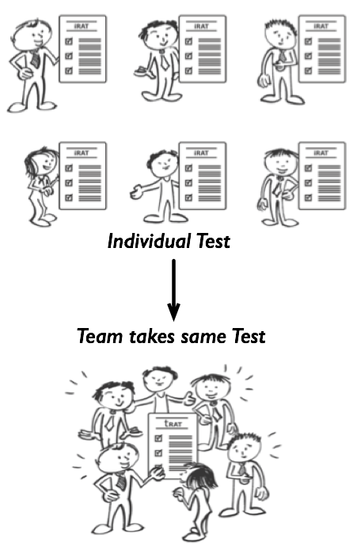
Stage 2: Individual Readiness Assurance Test

After completing the preparatory materials, students come to the first class session of a TBL module. They then individually complete a short 10-20 question multiple-choice test based on the readings. The RAP test is closed-book. At a very simple level, the Individual Readiness Assurance Test is about individual accountability for pre-class preparation. Did students complete the preparatory materials? The test should only focus on giving students the starting vocabulary and important foundational concepts they need to successfully begin problem-solving. Using the analogy of a book, the test should be constructed closer to the table-of-contents level than the index level. It is recommended that you stay away from picky details, and focus only the major concepts they will need to begin the problem-solving conversation. However, iRAT questions should still be slightly challenging. Overall, the average iRAT score is typically 65-75% and on the tRAT 85-95%.

Stage 3: Team Readiness Assurance Test (tRAT)

The team RAP test, or tRAT, begins immediately after the iRAT ends. The exact same questions are used for both tests.
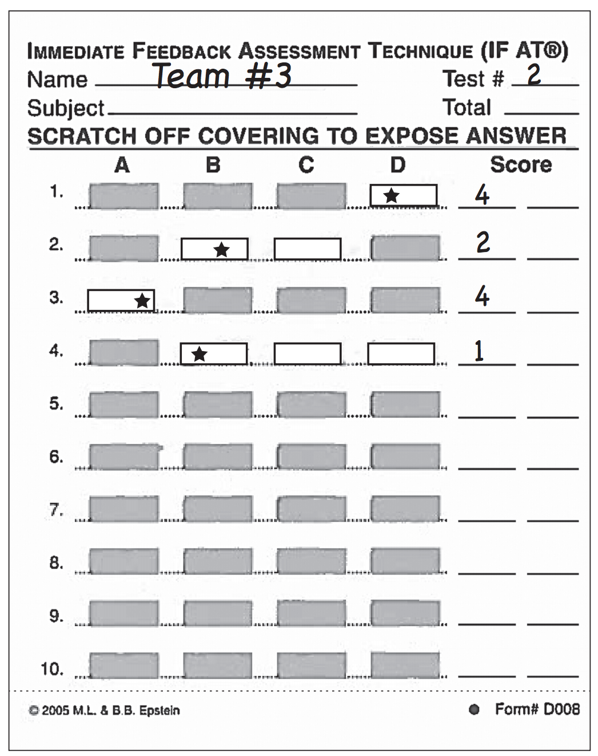
Team tests are high-energy, noisy, and often chaotic events as students discuss, think out loud, and negotiate their answers and thereby deepen their understanding. Typically, we budget 25 minutes for a 20-question team test, although we let students know that when half of the teams are done, the remaining teams have five minutes left to finish (5 minute rule).

A special kind of scoring sheet, known as an IF-AT form (Immediate Feedback Assessment Technique), is used for the team tests. IF-ATs are ”scratch-and-win” style scoring sheets. They dramatically increase the quality of discussion in the tRAT process and, more importantly, provide immediate corrective feedback. Students absolutely love using these test cards. You can expect high-fives and cheering as students complete the tRAT. We have even had some students thank us for the test! If you have not tried these, you must!
www.epsteineducation.com

Stage 4: Appeals Process

The appeals process is a structured method that provokes teams into looking up answers they got wrong on the tRAT. Near the end of the tRAT process, the teacher circulates around the room and encourage teams that may have gotten an answer wrong on the tRAT to consider appealing the question. The teams use an appeals form that is included in their team folder. The form describes in detail how to make a successful written appeal. Appeals are only accepted from teams, not individuals. To appeal a question successfully, the team needs to build a written rationale that makes a case that is supported with evidence from preparatory materials, for why a particular question’s answer might be wrong. They also could declare ambiguity in either the question or in the readings. To support these kinds of cases, they must make specific citations to the source of the ambiguity, or reword the question to eliminate the ambiguity. Appeals are collected by the teacher and considered only after class.

Stage 5: Mini-Lecture/Clarification

Following the appeals process, the teacher can provide a short, targeted mini-lecture or short clarification on the RAP concepts that the students are still having difficulty with. This lets teachers focus just on what the students don’t know, rather than on what they already know. Once Students are more familiar with TBL they are often excited and anxious to begin the more interesting 4S Application Activities and don’t want to have a mini-lecture. Going over every question or talking for too long can burn up student goodwill. A common mistake made by new TBL teachers is to sequentially review every question. Don’t do it. This can quickly drain energy from the class.

The total RAP process takes 50-70 minutes for a 20-question test. In shorter classes, teachers will often shorten the RAP test. For 50-minute classes, we often give 12-15 questions; this gives us time to complete the entire five-stage process.

Caution: The RAP prepares students for the activities that follow. It is not about testing. Students will become very upset if the RAP is presented as just another assessment strategy, rather than preparation for the activities that follow. If the RAP process is not carefully integrated with the activities that follow, you can expect to hear the unhappy student cry of “testing before teaching makes no sense!” You want to assign enough grade weight to the RAP that students engage seriously, but not so much grade weight that it becomes anxiety provoking, high stakes testing.

Protocol 2: 4S Application Activities

For creating an effective 4S Application Activity, the guiding principles in TBL are known as the 4S’s. Your Application Activities must be built using all 4S’s to get the most consistent and powerful results. The 4S’s are Significant Problem, Same Problem, Specific Choice and Simultaneous Report.

The majority of class-time is spent on 4S team application activities where student teams learn how to apply the course concepts to solve concrete and complex real-world problems. These application activities use something known as the 4S framework to structure and guide the problem-solving, decision-making, and reporting sequence. The 4S structure lets you consistently build problem-solving events that naturally lead to spirited discussions about the proper application of the course content to the specific situation or context. When you ask the right kind of question – one that requires both consideration of complex data and careful discrimination between reasonable options – powerful things can happen. The development of good questions and viable options that require deep, complex analysis is the holy grail of TBL.
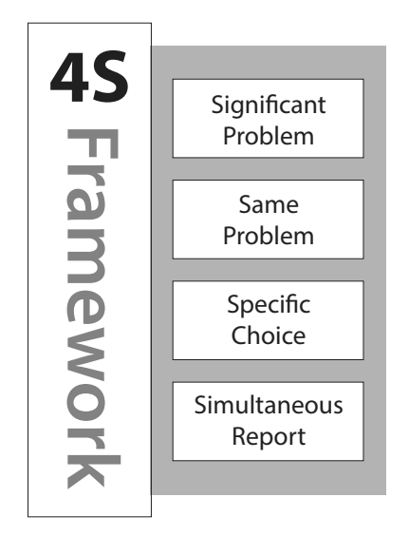
SIGNIFICANT PROBLEM - the problem must be meaningful to the students, and for their learning, and complex enough to require the whole team to engage. A trivial problem that can be solved by a single person working alone does not make a good 4S Application Activity. Rather, we should be seeking a complex, concrete problem that requires the analysis of multiple data sources, perhaps with incomplete or contradictory information, the balancing of trade-offs, and the consideration of the impact of each possible course of action before making a difficult decision. We use students differing perspectives, different prior knowledge, and life experiences to intensify their analysis of the situation where they need to decide on their “best” course of action when presented with a set of plausible, reasonable courses of action.

SAME PROBLEM - the entire class needs to work on the same problem at the same time. The rationale is that by having all teams work on the same problem, they will have a greater interest, engagement, and investment when it comes time for a class-wide reporting discussion. When each team completes their analysis, commits to a decision, and develops deep knowledge of the problem this readies them for a reporting discussion where they are prepared for a more informed critique of other teams decisions, not to mention a more engaged and passionate defense of their own decision if other teams arrive at a conflicting conclusion. This approach is in contrast to the common jigsaw practice outside TBL of having each team work on a different problem so they can share what they each have learned with the whole class; without having everyone work on the same problem, each team only becomes the “expert” of their own topic, which most often does not inspire interest, invite challenges, or examination of their decisions the same way that TBL does.

SPECIFIC CHOICE - requires that teams be able to express their solution to a problem by means of an easy-to-describe choice. Before giving some examples of what a specific choice might look like, it might be helpful to consider some examples that are not specific choices: a multi-page report, an oral presentation, a demonstration of a functioning device or process, or an ordered list, to name a few. Creating these deliverables may be valuable experiences for students and may even relate to some of the course outcomes, but they do not lend themselves well to TBL 4S Application Activities. Instead, the specific choice of a good 4S Application Activity requires that the team members all come to agreement on a single, clearly-defined answer (course of action) in light of potentially vague or conflicting information, where they find what they have learned so far from preparatory materials and RAP process may not be sufficient to solve problem at hand. Having this kind of discussion inside each team before the simultaneous report lets a variety of perspectives be explored and examined with a critical eye since the public report will expose their ideas to further examination and scrutiny. Having teams make a specific choice makes it possible to quickly see and compare responses between different teams (part of the next “S”). Posing what looks like a simple multiple-choice question is one of the most common ways to provide students with specific choices. Remember that the specific choices (distractors) need to be plausible, competitive courses of actions that might be appropriate in different contextual situations, not wildly disparate choices.

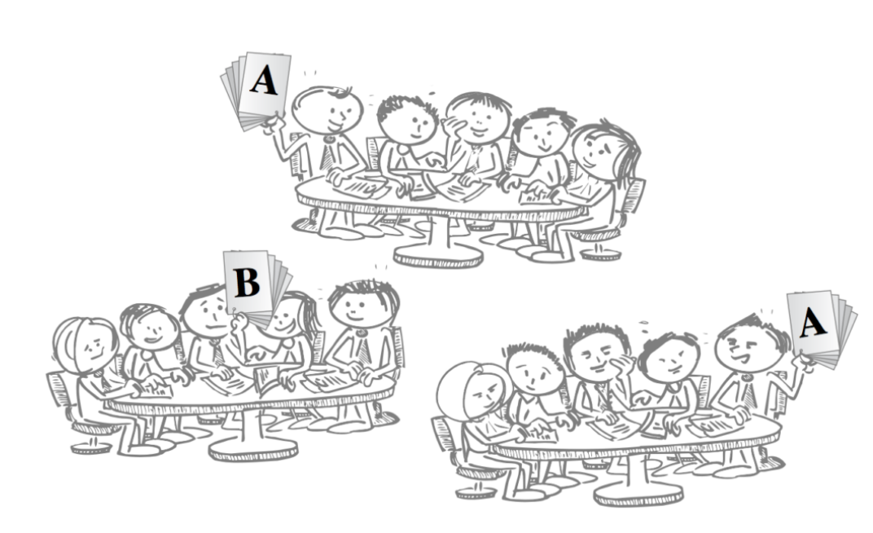
SIMULTANEOUS REPORT is the final “S”, and it requires that responses from all teams are reported to the class at the same time. Requiring the responses in the form of a specific choice (the previous “S”) makes simultaneous reporting possible. Simultaneous reporting encourages team accountability, since each team knows their response will be publically available for all to see, and no team wants to stand out with an unreasonable, hastily-chosen answer because they did not put the same thought into the problem analysis as the other teams. Put another way, the public commitment that comes with simultaneous reporting motivates the teams to seriously engage in the discussion inside their team prior to the report. There is also a fairness that comes with simultaneous reporting, since no one generally wants to be asked first when we do a sequential report. More importantly, there is no opportunity for later teams to unfairly modify their answer based on the responses of earlier teams, since everyone commits to their answer at the same time. Simultaneous reporting creates anticipation, excitement, and engagement; teams want to see how their response compares to those of their classmates. Techniques for achieving simultaneous reporting follow naturally from the type of specific choice the teams are asked to make. The simultaneous report can be as simple as teams holding up a numbered card indicating their team decision. A common facilitation approach to encourage a truly simultaneous report is to use the “last to report, first to talk” rule.

When teams simultaneously report their application activity decisions, any contrasts in thinking are immediately apparent. These contrasts then allow the instructor to easily facilitate an intense give-and-take discussion. During these application activities, you get to see the true power of TBL and the flipped classroom when teams are making decisions, publically committing to them, and then deeply discussing their decisions.

This is the TBL main event. Students solving big, messy, authentic problems. The great news about TBL is that it scales really well to large classes. Since the reporting of the 4S activities is based on student-to-student feedback – more students improve the depth of the reporting conversations.

Caution: Teachers who have long experience with using teams can take some missteps here. They may not want to fully embrace what they may see is protocols that are too prescriptive. Not maintaining fidelity to the TBL frameworks is a BIG mistake. The frameworks and classroom protocols ensure consistent, reliable, and powerful results. As teachers’ experience with TBL grows, they often report greater fidelity to the TBL frameworks and protocols, not less! (Sibley & Ostafichuk, 2014).

Creating the Right Conditions for TBL

Adhering to the two main TBL protocols (RAP + 4S’s) is essential. But there are other conditions that you need to create to optimize the TBL process. They are 1) teams must be properly formed, and 2) you need to ensure there is adequate accountability structures to induce good student behaviours.
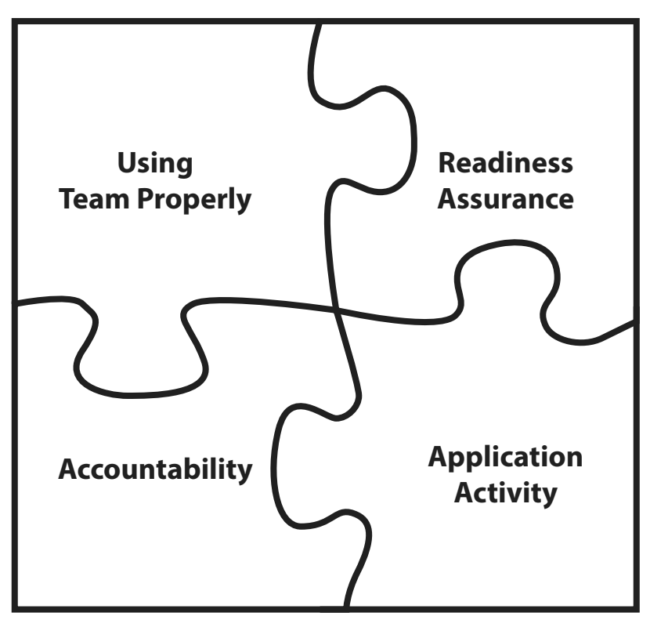
Teams must be properly formed

Team need to be carefully and thoughtfully formed to create the best conditions for a group of students to become high-performance learning teams.

Principle 1: TBL teams need to be large

Teams should have five to seven students. TBL teams need to be big enough to have the intellectual horsepower to solve the wonderful, complex, messy, real-world problems that are at the heart of every TBL course experience. TBL teams need to be larger than is suggested in most cooperative or collaborative learning literature because of the complexity of the problems teams are asked to analyze.

Intuition Alert: The recommended five-to-seven student size may be contrary to your intuition and own experience. But again and again, new TBL teachers who try smaller team sizes are often disappointed with the results. The major concern often expressed by teachers new to TBL is that if teams are too large some team members will not “pull their weight” (social loafing). Luckily, TBL with its protocols and structures effectively minimize these kinds of poor teaming behaviours.

Principle 2: TBL teams should be teacher-created

Use teacher-created, criterion-based team formation is important to ensure the best results. Teacher-formed teams have been shown to outperform randomly and student selected teams (Brickell, Porter, Reynolds, & Cosgrove, 1994; Fiechtner and Davis, 1985).

Student-selected teams are a very bad idea. Paraphrasing Brickell, student-selected teams consistently underperform other team formation strategies and student-selected teams are often “social entities” where existing relationships and cliques can make team cohesion difficult. Student-selected teams can be somewhat homogenous and this can easily lead to “group think” behaviors, since teammates on a student-selected team often have very similar in cultural, educational, and life experiences. These student-selected teams may not have the diverse range of talent and experiences they need to be successful with those messy real-world TBL problems.

Principle 3: TBL teams need to be diverse and balanced

We want to have maximum diversity in our teams to ensure that a wide range of skills, prior knowledge, opinions, and personal experiences can come into play during team deliberations. This is great news, since increased enrollment of under-represented groups and the recruitment of large numbers of international students are increasing diversity in our classrooms year after year. TBL actually gets better with more diverse teams, especially if we craft our activities to leverage that diversity.

You need to consider what each team will need to be successful and then design a team formation plan to fairly distribute those different strengths and weaknesses across all the teams. Does every team need to have a member with prior work experience, someone who has lived overseas, or someone with a previous degree?

Principle 4: TBL teams need to be permanent

To let the teams “gel”, the members must work together consistently. To allow this to happen, teams must be permanent for the duration of the course. This “gelling” process, known as team cohesion in the literature, takes time. With time, groups of students can become high-performance learning teams as the social overhead of interacting decreases and task focused energy increases.

Teams naturally, with time, practice, and especially feedback, get quickly better at problem-solving. TBL teachers often initially underestimating teams’ abilities to solve difficult problems, and needing to ratchet up the problem difficulty as the semester progresses.

A remarkable aspect of TBL is that teams don’t need to be managed at all. Unlike other forms of group learning, lecturing on group dynamics and assigning specific roles to team members is simply unnecessary. The combination of thoughtfully-created teams and the focus on decision-making activities eliminates the need for any kind of team management. This is because shared activities and goals, the sequence of TBL activities, and accountability to one’s team all synergistically aid in the development of team cohesion. There was a remarkable study that highlights the amazingly rapid development of team cohesion in TBL (Michaelsen, Watson, & Black, 1989). The study found that in early Readiness Assurance testing, student teams often used simple votes on split decisions and let the majority rule. But as team members found their social feet within the team and team cohesion began to increase with each testing cycle, the decision-making process progressively switched to a more consensus-based decision-making process. It showed that in as few as four Readiness Assurance cycles, teams had switched strategy from majority rules to consensus-based decision-making. The focus on process-oriented activities like analysis, decision-making, and discourse prevent much of the team dysfunction common to more product based team outputs.

Ensuring Accountability

Creating adequate accountability structures is crucial to a successful TBL implementation. There are three things we should do in the TBL classroom.
- Students must be encouraged to individually prepare.
- Students must be encouraged to contribute to their team.
- Students must be made aware that they will be accountable for their contributions to their team.
In order to accomplish these goals, we must incorporate three corresponding measures into the overall course design and accountability structures to ensure that we encourage the behaviours we want. These are:
    - Students need to be rewarded for their Individual performance
    - Students need to be rewarded for their Teams performance
    - Students need to be reward fairly for their contribution (or lack of contribution) to their team’s success
The important measure of an individual’s performance comes from the individual Readiness Assurance Test scores. These scores give instructors a measure of individual accountability for the quality and completeness of each student’s preparation. This component must be a substantial enough portion of the final grade so that a student feels compelled to prepare, but not so large that the Individual Readiness Assurance Test (iRAT) turns into anxiety provoking high-stakes testing. There are often other traditional measures of individual performance that are not related to the TBL portion of the course, including individual assignments, midterms, and final examinations.

Students are sometimes shocked at first at the low individual scores on the iRATs. Typical averages are 65-70%; that’s perfectly normal. Students may need to be reassured that the RATs are working as designed, and that they constitute only a small portion of their final grade, and will be tempered by the higher team grade on the tRATs (typically 85-95%) score.

The team performance measures come from all team activities that are graded. These include the team Readiness Assurance Test (tRAT) scores and, in some courses, graded 4S Application Activities.

The measure of a member’s contribution to their team typically comes from a peer evaluation process. Peer evaluations hold students accountable for their level of participation. Peer evaluations also reassure students that social loafers won’t unfairly benefit from the higher grades on team activities. Teammates can quickly tell who is prepared and who is pulling their weight. Accountability to your peers can be much more powerful than accountability to the teacher. It is also important to use peer evaluation and give the grading scheme enough teeth to motivate every student to contribute and be fairly rewarded (or penalized) for their level of contribution to their team’s success.

Does Team-Based Learning Really Work?

TBL is a research proven method that both increases engagement and learning.

- Students are more engaged. Students reported higher level of engagement in TBL courses (Chung et al., 2009; Clark et al., 2008; Kelly et al., 2005; Levine et al., 2004).
- Increased excitement in the TBL classroom. Teachers report increased excitement and engagement in their classrooms (Andersen et al., 2011; Dana, 2007; Jacobson, 2011; Letassy et al.; 2008; Nicoll-Senft, 2009).
- Teams outperform best members. The worst team typically outperforms the best student. In 20 years of results Michaelsen (1989) found that 99.95% of teams outperformed their best member by an average of 14%.
- Students perform better on final and standardized exams. TBL students outperform non-TBL students on examinations (Grady, 2011; Letassy et al., 2008; Persky, 2012, Zingone et al.; 2011, Koles et al., 2005; Koles et al., 2010; Thomas & Bowen, 2011).
- A large class can be viewed as an asset by students - Michaelsen, Knight, Fink (2002) found that students actually perceived a larger class size as beneficial to their learning with TBL.

Why Team-Based Learning Works so Well

To better understand all that is going on in the TBL classroom, let’s examine the two major protocols more closely. Let’s first look at what occurs during the Readiness Assurance process that makes TBL so powerful.

It is the start of another TBL module in Professor Kumar’s course. It is the first lecture of the week and students are filing into the classroom for the Readiness Assurance test. At the top of the hour, they are asked to put their books and phones away to get ready for the iRAT. The question sheets and answer card are distributed, students are instructed to begin, and the timer on the screen begins to count down. When time expires, students are asked to put their pencils down and pass their iRAT answer cards to the front of the room (they keep their question sheet). The IF-AT cards are then distributed (one per team) and the tRAT begins. Noise erupts. The volume in the room gets quite loud as teams discuss, negotiate, and commit to their answers. There are cheers, groans, sighs, and high fives as teams work through the questions. Once the timer on the screen again counts down to zero, the IF-AT cards are collected (along with ALL question sheets) and the Appeals Process begins where students are encourage to appeal any questions they got wrong using the instructions and form in their team folder. Finally Dr. Kumar gives a short mini-lecture and reviews the few remaining troublesome topics from the readings and RAP. Now the students are ready for the 4S activities.

The iRAT’s provides individual accountability for each student’s pre-class preparation. Simply put, if you don’t prepare, you probably won’t do well on the iRAT. The focus of the Readiness Assurance Process also cues students to the most important concepts to get started.

During the tRAT stage, some very interesting and powerful educational outcomes begin to emerge. First, through social dialogue and peer teaching, students generate a deeper shared understanding as they try to come to a consensus on the answer for a particular question. Next, if you are using IF-AT cards, the teams receive immediate corrective feedback on each question. Students leave the test knowing the answer to every question; you can’t get more immediate than that!

The IF-AT cards also help establish more positive group norms. The pushy student with a few wrong answers may be a few scratches away from having the team stop listening. Similarly, a quiet student can be drawn into the conversation if the team recognizes that they often have the right answers and that listening to the quiet student will help the team. Finally, the chronically underprepared student is usually found out by their teammates, and peer pressure and peer evaluation can sometimes motivate these underprepared students to work harder.

Another powerful piece of team testing is the levelling process that occurs between team mates. Having team members at different levels of preparation and understanding can be quite toxic to subsequent team activities. The team test serves to get each team member on the “same page” with peer teaching, consensus building, and the fact that every person knows the answer to every question by the end of the RAP test, thereby helping all team mates become more evenly ready. Turning individual preparation into true team readiness to begin problem solving is what the readiness assurance process is all about.

The magic of the Appeals Process is that it pushes students back into the reading or other preparatory material, right where they are having the most difficulty. These difficulties are clearly identified by questions they got wrong on the tRAT. Teams must look up the concepts they still don’t understand. They may research the answer only to find that the teacher is correct, or they may unearth a genuine ambiguity. They need to build the appeal by reviewing both the preparatory material and the question, and by building a case supported with evidence.
By the end of the first four RAP stages, both student and teacher have a clearer understanding of which course concepts continue to be difficult. The students have had extensive feedback during the tRAT process and an opportunity with the appeals process to clear up many misconceptions. But some troublesome concepts can remain. These can be clarified during a short mini-lecture that closes out the Readiness Assurance Process. The power is that the clarification focuses on what the students know they don’t know. It doesn’t waste class time on things they already understand.

Next, let’s look at all the learning that occurs during 4S Activities.

Dr. Kumar displays the next 4S question on the screen. She instruct the students on how long they have to complete their analysis, directs their attention to the specific choices, reminds team they will need to ultimately make a decision, and commit to one “best” answer. Then she describes the mechanics of the simultaneous report and how teams will report their decision. The timer is started and the teams begin their discussion, complete their analysis, make required judgments, and finally (hopefully) reach consensus position and commit to one of the specific choices. When time runs out, Dr. Kumar ask team reporters to get ready and on the count of 3 have teams hold up one voting card that indicates their team decision. Dr. Kumar pauses for a moment to let students take in the patterns they see and the different decisions that have been made. Dr. Kumar begins to speak – first announcing the patterns she sees- then ask different teams why they made their particular decision – asking what evidence they used – what they are sure about – what they had to infer. The conversation moves team to team as contrasts in thinking and rationales used are examined. Periodic summaries help the students see helpful patterns as they begin to emerge. The activity closes with a summary of what has been learned. How the evidence can be used to support a reasonable position and make a good decision, how context can effect which decision is best, and what information is missing and could really help with these kinds of decisions in the future.

You need to present a problem/scenario that creates the context in which what students “know” abstractly (via their readings) is put to the test when they try to “use” it in the concrete, specific case. Your job is to find or, if necessary, fabricate these scenarios.

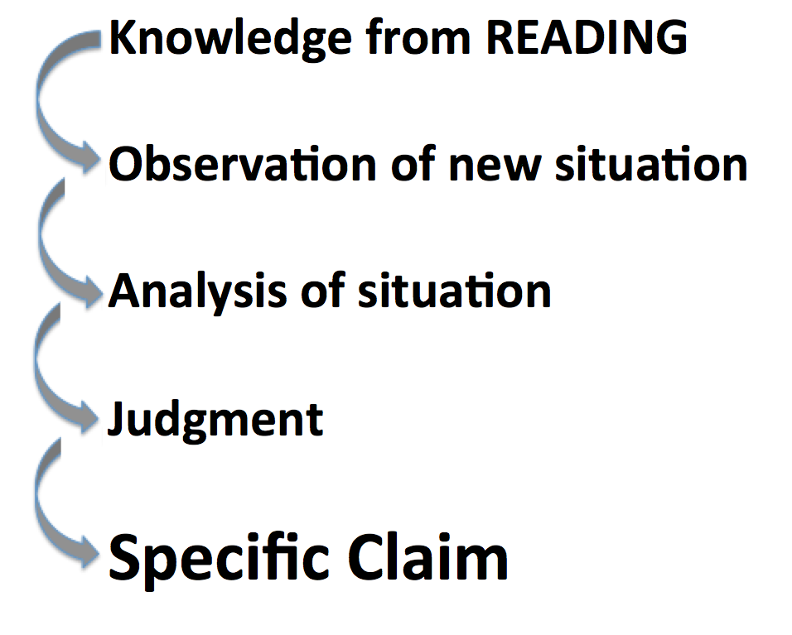
It is worth remembering, that during the 4S Application Activities, students will be looking stuff up and continuing to learning. The students are motivated by their own interest and the knowledge that their understanding will be on public display during the Application Activity reporting. This is a powerful motivator for students to take continued learning seriously.

To help students become better problem-solvers what is needed is immediate and focused feedback on the quality of your thinking and decision-making. The TBL 4S protocol ensures this kind of feedback is frequent. Helping students see gaps in their knowledge motivates students to look up what they don’t know and then immediately putting that knowledge into action tests and deepens their understanding.

Now let’s look at a series of 4S prompts from different disciplines. What we want to notice here is how superlatives or implied superlatives force teams to complete a specific analysis and make a specific choice. Not some vague, what would you do in the situation? But the more focused - what would be the BEST/WORST/FIRST thing to do in this situation? Consider how much more focused the analysis by student teams will need to be as they make this kind of specific choice and construct a robust rationale that will stand up to public scrutiny during the simultaneous reporting and follow-up discussion.
- A patient comes into emergency with the following symptoms...
    - What is the first thing you would do? And why?
    - What is the first test you would order? And why?
    - What would be the worst thing to do? And why?
- Given 3 possible programs to end homelessness in your city, select the program that is the best and will likely be most strongly supported by local agencies and Civic leaders? (Michaelsen and Sweet)
- What is the most relevant theory that explains the behaviour in the video? (Kubitz and Lightner)
- Which of the following best describes the opportunity cost of coming to class today? (Espey)
- Which of the following should the University do to best increase the quality of Undergraduate education? (Mahler)
- Which sampling scenario would best address this research project? (Mahler)
- Given three valid historical interpretations of the progressive Movement, discern which best describes the Progressives revealed in our manifesto? (Restad)
- In Clarence Page’s op-ed piece “The Problem With Trashing Liberty”’ where does the responsibility for a safe a civil society lie? Which of the following three philosophers (X, Y, and Z) does Clarence Page most agree with on these fronts? (Roberson and Reimers)
- What of the following passage in the Bhagavad Gita best illustrates reflection about the nature of Krishna’s divinity? (Dubois)
- Rank how useful each source is for understanding the fears of the Cold War era. (Restad)
- Which teacher should be nominated for a teaching award? (Croyle and Alfaro)
- Which indicator (from a list of 5 plausible alternatives) is most critical to making a correct diagnosis in this case? (Michaelsen and Sweet)
- If a moving vehicle overloaded this bridge structure, which component would likely fail first?
- You are making a home assessment, which of the following safety hazards would be of greatest concern? (Clark)
- After assessing Mrs. Randall’s dining room what would be your first recommendation to protect her from falls? (Clark)
- What line on this tax form would pose the greatest finical risk due to an IRS audit? (Michaelsen and Sweet)
- Given a set of real data, which of the following advertising claims is least (or most) supportable? (Michaelsen and Sweet)
- You are consulting for a new business owner who wants to open a dry-cleaning store in Norman, Oklahoma. Where would you recommend locating a new dry-cleaning business? (Michaelsen)

Common concerns about adopting TBL

If TBL is so good, why isn’t it more popular? This is a very reasonable question to ask.

First, you might think that some of TBL advice doesn’t quite sound right. Big teams of 5-7 probably runs counter to much of the advice you have heard for years from “experts” as they describe ideal team size for Cooperative Learning. We need to keep in mind that TBL and Cooperative Learning are very different in what they are asking teams to do, since Cooperative Learning often is more product focused in contrast to TBL’s analysis and decision focus. TBL teams need to be this big to manage the intellectually challenging activities that are central to TBL.

The second problem is the big shift in your own teaching practice that adopting TBL requires. This is not a pedagogy you sprinkle over an existing course, but a complete rethinking of what the main course goals are (learning to apply course concepts), a shift in how your course is delivered (using TBL’s unique activity structures) and the willingness to change your classroom role from expert - sage on the stage - to the designer and facilitator of high quality learning activities. This shift can be especially uncomfortable when some students may be voicing their resistance to becoming active and responsible for their own learning – “it is your job to tell us the right answers”

Third, teachers can feel intense pressure from their colleagues to “cover” the content. A common discomfort of TBL adopters is you don’t feel like you get to teach everything. Students learn much of the content in their own in their efforts to solve the 4S problems. You don’t get to say it, but the students do learn it! This is backed up by the research – TBL student perform better on standardized exams and in multi-section courses the TBL sections get more covered.

These can be formidable barriers to adoption, in spite of how extremely positive the change can be for student learning, the intensity of engagement, and increase in instructor satisfaction can be a surprise for faculty. Here are a few quotes that try illustrate how fun, joyful, and effective TBL can be:

The enthusiasm and energy of students. It’s just so much fun!
Larry Michaelsen - University of Central Missouri

Students excited about learning, faculty falling in love with teaching, the way learning should be.
Holly Bender - Iowa State University

Students are so engaged in conversation with each other and the task that, literally, they don’t know I am there. My favorite days are when I have to tell them to leave.
Laura Madson - New Mexico State University

I think the genius of TBL is that it maximizes the advantages of group learning while minimizing the disadvantages.
Brent Maclaine - University of Prince Edward Island*

Last Words of Advice

Team-Based Learning is not last-minute pedagogy. You won’t be word-smithing PowerPoint decks just before class sessions. It requires a commitment to plan and develop your materials early so they can be well integrated into a powerful learning experience. Give yourself this gift of time.

You don’t have to do this alone. Build a support network early. It might be a like-minded colleague or someone from your local Teaching and Learning center, but make sure you find someone to share your work with to get some feedback before taking things to class. Nothing is more uncomfortable than rushing poorly thought-out materials to class and experiencing the wrath of unhappy students.

Even if you are lucky enough to have someone locally, it is still important to reach out to the international TBL community. TBL practitioners are extremely generous with their time and commitment to helping newcomers. The best way to get connected is to join the free TBL listserv (www.learntbl.ca/listserv). Often peoples first post is “I am new to TBL and teach X. Does anyone out there out there have advice or TBL materials they would be willing to share?” You will be surprised at how caring and helpful this list can be. Often there are helpful questions and answers after someone posts something like “this happened in class today – what should I do?” Often a flurry of advice and reassurance flow back to the person who had the question.

There are also many places to learn more about TBL. Two websites are particularly helpful – www.learntbl.ca and www.teambasedlearning.org. There are numerous good books on TBL, the most recent being Getting Started with Team-Based Learning by Jim Sibley and Pete Ostafichuk. There are other places worth looking to understand more – eric.edu.gov – try searching “team-based learning + your discipline”. There are thousands of TBL articles in the ERIC database. Finally try searching on YouTube – there are many helpful videos that highlight many different aspects of TBL.

I hope this article has convinced you to learn more about Team-Based Learning, so you can give it a try to share in the fun, excitement, satisfaction and deep learning that TBL teachers and students enjoy.

Disclaimer:

This work represents my current understanding and builds on ideas and words from my handouts and workshop materials that I have created over the last 15 years. Much of this material is the compilation, extension, and refinement of my existing writings. Three notable sources were used, my “Introduction to Team-Based Learning” handout which was first developed for a 2012 workshop at the American University of Technology in Beirut, Lebanon (Sibley, 2014), and “A concise guide to creating a TBL module” handout created for a 2016 TBL Institute at Vancouver Island University (Roberson and Sibley, 2016) and many postings from my personal website (learntbl.ca).

Note:
*Faculty quotes are from the book - Getting Started with Team-Based Learning.

References:

Andersen, E. A., Strumpel, C., Fensom, I., & Andrews, W. (2011). Implementing team based learning in large classes: Nurse educators’ experiences. International Journal of Nursing Education Scholarship, 8(1).

Brickell, J. L., Porter, D. B., Reynolds, M. F., & Cosgrove, R. D., (1994). Assigning Students to Groups for Engineering Design Projects: A Comparison of Five Methods. Journal of Engineering Education, 7, 259-262.

Chung, E. K., Rhee, J. A., Baik, Y. H., & Oh-Sun, A. (2009). The effect of team-based learning in medical ethics education. Medical Teacher, 31(11), 1013–1017.

Clark, M. C., Nguyen, H. T., Bray, C., & Levine, R. E. (2008). Team-based learning in an undergraduate nursing course. Journal of Nursing Education, 47(3), 111–117.

Dana, S. W. (2007). Implementing Team-Based Learning in an introduction to law course. Journal of Legal Studies Education, 24(1), 59–108.
Fiechtner, S. B., & Davis, E. A. (1985). Why some groups fail: A survey of students' experiences with learning groups. The Organizational Behavior Teaching Review, 9(4), 75-88.

Grady, S. E. (2011). Team-Based Learning in pharmacotherapeutics. American Journal of Pharmaceutical Education, 75(7), Article 136.

Jacobson, T. E. (2011). Team-Based Learning in an information literacy course. Communications in Information Literacy, 5(2), 82–101.

Kelly, P. A., Haidet, P., Schneider, V., Searle, N., Seidel, C. L., & Richards, B. F. (2005). A comparison of in-class learner engagement across lecture, problem based learning, and team learning using the STROBE classroom observation tool. Teaching and Learning in Medicine, 17(2), 112–118.

Koles, P., Nelson, S., Stolfi , A., Parmelee, D., & DeStephen, D. (2005). Active learning in a Year 2 pathology curriculum. Medical Education, 39(10), 1045–1055.

Koles, P., Stolfi , A., Borges, N. J., Nelson, S., & Parmelee, D. X. (2010). The impact of Team-Based Learning on medical students’ academic performance. Academic Medicine: Journal of the Association of American Medical Colleges, 85(11), 1739–1745.

Letassy, N. A., Fugate, S. E., Medina, M. S., Stroup, J. S., & Britton, M. L. (2008). Using Team-Based Learning in an endocrine module taught across two campuses. American Journal of Pharmaceutical Education, 72(5), 1–6.

Levine, R. E., O’Boyle, M., Haidet, P., Lynn, D. J., Stone, M. M., Wolf, D. V., & Paniagua, F. A. (2004). Transforming a clinical clerkship with team learning. Teaching and Learning in Medicine, 16(3), 270–275.

Michaelsen, L. K., Watson, W. E., & Black, R. H. (1989). A Realistic Test of Individual Versus Group Consensus Decision Making. Journal of Applied Psychology, 74(5), 834-839.

Michaelsen, L. K., Knight, A. B., & Fink, L. D. (Eds.). (2002). Team-Based Learning: A transformative use of small groups. Westport, CT: Praeger.

Nicoll-Senft, J. (2009). Assessing the impact of Team-Based Learning. Journal on Excellence in College Teaching, 20(2), 27–42.

Persky, A. M. (2012). The impact of Team-Based Learning on a foundational pharmacokinetics course. American Journal of Pharmaceutical Education, 76(2), 1–10.

Roberson, B., Sibley, J. (2016) Workshop handout – Guide to creating a TBL module. Retrieved from http://learntbl.ca/wp-content/uploads/2014/06/Part2_4S_module_creating_reading_v0.7.docx

Sibley, J. (2012) Workshop handout – Introduction to Team-Based Learning. Retrieved from http://learntbl.ca/wp-content/uploads/2014/06/TBL-handout_February_2014_lettersize.pdf

Sibley, J., Ostafichuk, P. (2014) Getting Started with Team-Based Learning. Sterling, VA: Stylus

Sibley, J. (2014) website – lerantbl.ca

Thomas, P. A., & Bowen, C. W. (2011). A controlled trial of Team-Based Learning in an ambulatory medicine clerkship for medical students. Teaching and Learning in Medicine, 23(1), 31–36.
Zingone, M. M., Franks, A. S., Guirguis, A. B., George, C. M., Howard Thompson, A., & Heidel, R. E. (2010). Comparing team-based and mixed active-learning methods in an ambulatory care elective course. American Journal of Pharmaceutical Education, 74(9), Article 160.

Appendix One

Concise Guide to Building TBL modules

When we first try to envision a TBL module, it can be helpful to imagine the module as a tapestry of learning. Our first task is to create each thread that the tapestry of learning will be woven from. A single thread links a Learning Outcome, to specific preparatory materials (readings or other things), to the Readiness Assurance Process questions, and finally to 4S activities.
The Learning Outcomes defines where we want student to go, the careful combination of a reading and Readiness Assurance questions get students ready to apply what they abstractly know, and the powerful 4S learning tasks then lets students put their abstract knowledge to work in the concrete world and show us they really know.
We design backwards - first by defining the desired Learning Outcomes, then turning our attention to the creation of a 4S task, and finally selecting the readings and creating the Readiness Assurance questions to ready the learners. Let’s look at an example to help you envision the required steps in the development of the pieces.

Steps 1-3: Create Learning Outcome
Creating great learning outcomes is a cyclic, iterative process where you need to continuously revisit and refine your initial learning outcomes as your course design proceeds. Your first provisional outcomes are used to begin building other components of course design – selecting teaching and learning activities, and designing assessment methods and materials. As all the components begin to come into focus, you will periodically revisit and refine your initial learning outcomes, revisit and refine teaching and learning activities, and tweak and refocus final assessment methods and materials.
Learning outcomes are focused on student achievement and by the end of module development will become more detailed and describe exactly what the students will be able to do by module end. Learning outcomes often contain references to the knowledge, skills, and judgment abilities you want your students to develop and ultimately show you so you – know they know. Some of your initial learning outcome will become the precursors to ideas for 4S Application Activities.
When we start thinking about the 4S Application tasks, we want to try to write learning outcomes that focus on more concrete actions rather than abstract understanding. We are looking for concrete actions just like a discipline expert takes. Good learning outcomes express how experts in your field or discipline would use the course content to solve disciplinary problems. The more concrete you can make the learning outcomes the easier it will be to develop 4S Application tasks from them.
Step 1: Create a basic Learning Outcome

At a very simple view – writing a learning outcome can be as simple as attaching a Bloom’s verb to a piece of a piece of content. Consider: I want students to know about flood return periods, I could simply add the Bloom’s verb “define” to flood return period.
Define + Flood Return Period = Learning Outcome
This is a very typical content focused, low Bloom’s level learning outcome.

Step 2: Raise the Bloom’s level of Learning Outcome

Explain Flood Return Period

In this step, we raise the Bloom’s level of the verb used. In this example, the change has moved the learning outcome from the lowest Bloom’s level – Remember - to the slightly higher Understand level.

Step 3: Make Learning Outcome about Action

Demonstrate understanding of Flood Return Period

In this step, we change the learning outcome to be about concrete action rather than abstract understanding.
In this example selecting a verb like “demonstrate”, but this doesn’t provide any information on how the students might “demonstrate understanding”. It is time to think about how to make student thinking more visible. We do this by imaging a 4S task that will give students the opportunity to use what they know, extend their knowledge, and finally show us they know (achieve learning outcome).

We now want to think about our discipline and the kinds of questions experts are routinely asked to make, the kinds of data they work with, the inferences, judgments, and especially decisions they are required to make. These will ultimately be the source of your inspiration of what makes a great 4S task.

Steps 4-5: Design 4S Application Activities

Step 4: Create a provisional 4S question prompt with a superlative

It is worth remembering we want the question prompt to constrain the decision space, so the reporting analysis and discussion is more focused on salient issues. Think about the difference that would occur when we imagine the reporting conversation for “what would be the best thing to do in this situation?” versus the more diffuse “what would you do it this situation?”

Combining the identified disciplinary action with the desired learning outcome, it is time to go shopping for a 4S question prompt. You want one that contains a superlative (Best, First, Worst, etc.) that will make students analyze, discriminate, and finally report a reasonable choice or course of action.

- Which of the following would be the - Best, Worst, First, Most effective, etc. – thing to do or reasonably conclude or to interpret, etc. - in this specific, concrete situation?

Step 5: Use template to create other 4S question parts

Once we have a question prompt in mind, we can start completing the other pieces of a complete 4S question.

It is worth noting that the specific detail you add to the scenario can guide students to analyze the problem a certain way using the provided detail or pointers to data sets. Similarly, the mix of different course of action/decisions possibilities can have students naturally examine the situation from a specific set of perspectives that you have intentionally pointed them towards.
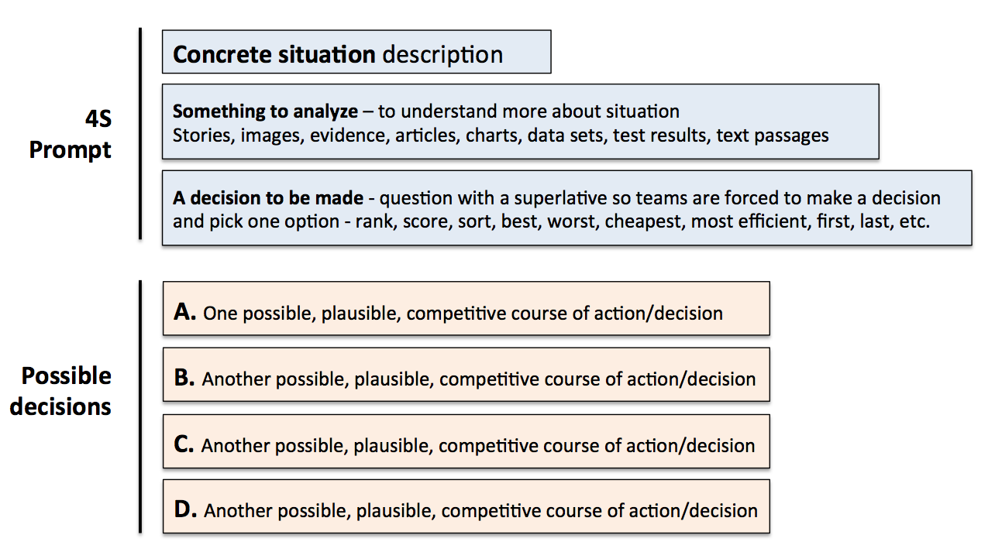

Steps 6-8: Design Readiness Assurance Sequence

Step 6: Determine important concepts to test

By looking at the 4S task you are creating, you can identify what concepts, definitions, and vocabulary the students will need to start their analysis discussions. Make a preliminary list. This is not everything they need to solve every activity, but what they require as an entry point to the problem-solving conversation. You do this by mapping back from the 4S Application Activity to important foundational knowledge that the students will need to be successful. When you are clear on the basic knowledge students need to know, you are then ready to select appropriate student preparation materials and then construct RAP questions.

Step 7: Select Appropriate Reading
There is an iterative loop as you select/define/refine the concepts to be initially tested, and then select and refine the preparation materials. For preparation materials, we most often use readings, but videos, lecture recordings, or narrated PowerPoint’s can work well. Knowing what concepts, definitions, and vocabulary your students need to get started – try to find a concise reading that has sufficient detail (not too much) and is at an appropriate reading level to be accessible to your students.

Over the years we have discovered that less is more with readings. The amount of readings that students will tolerate depends on the particular discipline and institutional context. Our readings are closer to 25 pages for 2 weeks, which is down from our original 75 pages for two weeks. We found that students were spending a short, fixed amount of time completing readings without regard for complexity and length of readings.

Step 8: Create a variety of Readiness Assurance questions

Time to write a few multiple-choice questions for the Readiness Assurance test. Questions should be a mix at mostly Bloom’s levels – remember, know, and some light application. Remember the RAP test is not about testing all that students will learn in the module, but instead only what they need to begin effectively problem-solving (4S Application Activities). It is important to pitch the RAT at the right level to encourage students to engage deeply but not so difficult that they lose heart.

