Creating a TBL Module

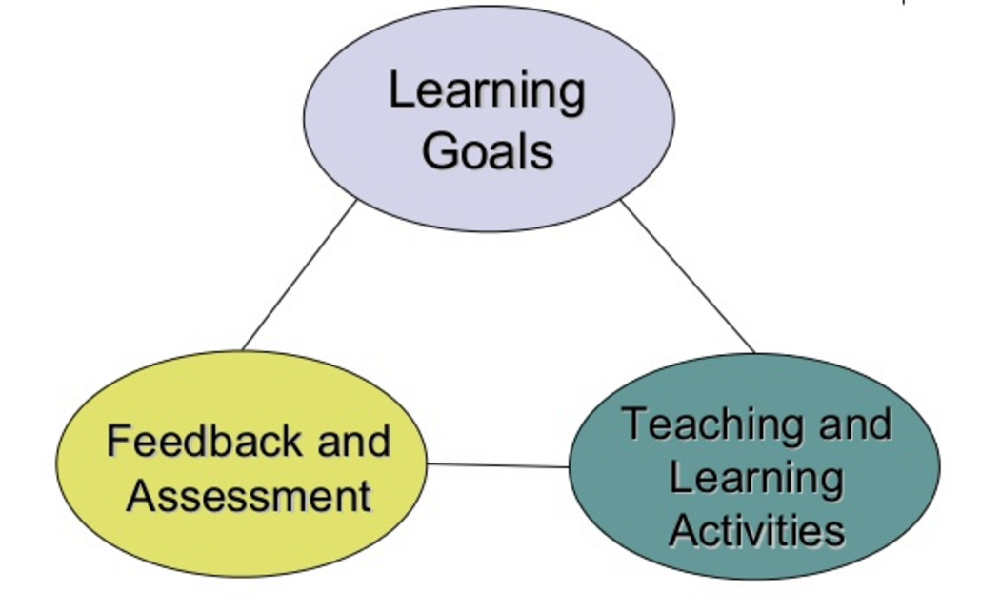
Using Backward Design is essential to developing a good TBL module. First, we need to consider "what I want the students to be able to do" by the end of the module, then "how will I know they can do it", then "what opportunities do I need to provide to help them learn and succeed”. Fink’s work (2003) reminds us that we must ensure that these three aspects of course design – Learning Goals, Feedback and Assessment, Teaching and Learning Activities - are well integrated and mutually reinforcing. We need to develop teaching and learning activities that give students the learning opportunities they need to prepare them to show us all they have learned.

Typical Module Progression
The typical 2-week TBL module start with students completing assigned pre-readings or other preparation materials, and then at the first class meeting they complete the Readiness Assurance Process (multiple choice test). By the end of the Readiness Assurance Process we have some "assurance" that your students have the required minimum foundational knowledge to begin problem solving. The rest of the module focuses on having students use the course concepts to solve problems structured using TBL’s 4S framework. During the problem-solving process the instructors will sometimes provide very short mini-lectures/expert clarifications when teams are having difficulty progressing. The module ends with a short instructor-led review of all that has been learned. TBL modules always have the same progression of activities - student pre-class preparation, Readiness Assurance Process, and 4S team tasks.

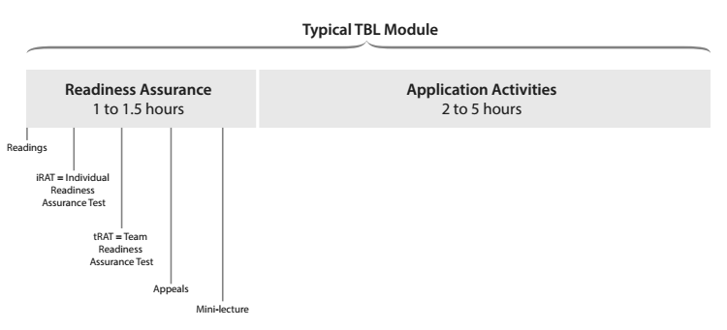

Backward design steps for a TBL module
- Develop Aims and Learning Outcomes.
- Consider situational factors
- Develop your Instructional Aims
- Develop student Learning Outcomes
- Design 4S Application tasks/activities.
- Design 4S team Application tasks/activities

- Develop Readiness Assurance Process.
- Create/select advanced preparation materials
- Write RAP questions

1. Develop Aims and Learning Outcomes
First, you need to develop your Instructional Aims. Aims are your general instructional intentions for the module. Aims are always written from the point of view of the teacher, the things you hope to achieve as a teacher.

Next, you develop Learning Outcomes. Learning Outcomes focus directly on the students and get more detailed on exactly what the students will be able to do by module end. Learning Outcomes often contain references to the knowledge, skills, and judgement abilities you want your students to develop. These Learning Outcome statements are often the precursors to ideas for 4S Application tasks. When we start thinking about the 4S Application tasks, we want to try to write Learning Outcomes that focus on more concrete actions rather than abstract understanding. We are looking for concrete actions just like a discipline expert takes. Good Learning Outcomes express how experts in your field or discipline would use the course content to solve disciplinary problems. The more concrete you can make the learning outcomes the easier it will be to develop 4S Application tasks from them.

Note below how concrete, active Learning Outcomes use verbs that are already the seeds for 4S Application task development!

Sample Learning Outcomes for a statistic course: by the end of this course students will be able to use their knowledge of statistical principles to:
- Complete a statistical analysis
- Select an appropriate sampling plan
- Develop a survey instrument and plan to gather information from a specific population

Sample Learning Outcomes for a genetics counselling course: by the end of this course students will be able to use their knowledge of genomics to:
- Interpret genome sequencing data
- Identify genetic markers with greatest risk of disease/abnormality
- Develop counselling plan to work with specific family issues
Sample Learning Outcomes for a business course: by the end of this course students will be able to use their knowledge of marketing principles to…
- Conduct a market analyses
- Evaluate a marketing plan
- Select or Develop marketing techniques to reach specific populations of clients

Sample Learning Outcomes for a history course: by the end of this course students will be able to use their knowledge of early Canadian history to…
- Interpret written accounts of historical events in light of cultural dynamics
- Assess (and estimate) the bias or orientation of a given author
- Develop arguments for current policies or political positions based on historical context

2. Design 4S application activities/team tasks
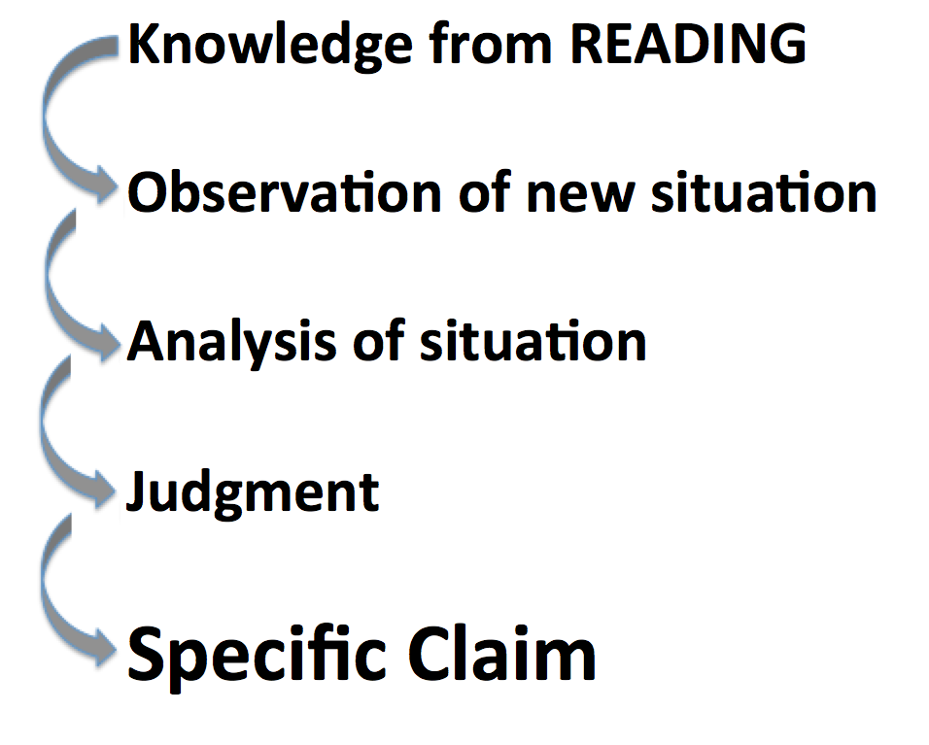
During a 4S Application task, students get to concretely apply what they have abstractly learned from the readings. Because of the abstract nature of understanding, it is not “teachable” in the conventional sense. An understanding can be gained only through guided inference whereby the learner is helped to make, recognize, or verify a conclusion. (Wiggins and McTighe, 2013). You want students connecting abstract concepts from the readings with concrete experience during the 4S team Application tasks. Making connections during 4S team tasks is important to consolidate student learning. Helping students see gaps in their knowledge motivates the students’ look up what they don’t know and then immediately putting that knowledge into action tests and deepens their understanding. You need to present a scenario that creates the context in which what students “know” abstractly (via their readings) is put to the test when they try to “use” it in concrete, specific case. Your job is to find or, if necessary, fabricate these scenarios.

4S Extended Example

Students in Sociology might “know” Maslow’s hierarchy of human needs, and could score well on a test that asked them to recite and explain it. But now imagine the Application task you give students, based on their initial understanding of Maslow:

You are a social worker and you have been given the case of “Maria from Syria.” Given your understanding of Maslow’s hierarchy, look at these data, make an assessment of her situation, and decide the best way to proceed in interacting with her: “Maria comes from a middle class family (her father was a dentist) in a small town in war-torn Syria. She immigrated with just her two children to Canada 2 years ago, and came to Ontario. She now works long hours at minimum wage as a housekeeper. She recently re-married and currently lives with her abusive, alcoholic husband. One of her children has health problems...etc.”

If the details of the case are rich, it quickly becomes clear to students that Maria’s case is complicated, and that Maslow’s hierarchy, while it is a useful tool to help analyze the situation, does not lead to an easy assessment or judgment. We seek questions that make students want to actively pursue an inquiry, and willingly learn content along the way in service of inquiry (Wiggins and McTighe, 2013).

Example 4S prompts (note the use of superlatives or implied superlatives to force a specific choice)

- A patient comes into emergency with the following symptoms...
  - What is the first thing you would do? And why?
  - What is the first test you would order? And why?
  - What would be the worst thing to do? And why?
- Given 3 possible programs to end homelessness in your city, select the program that is the best and will likely be most strongly supported by local agencies and Civic leaders? (Michaelsen and Sweet)
- What is the most relevant theory that explains the behaviour in the video? (Kubitz and Lightner)
- Which of the following best describes the opportunity cost of coming to class today? (Espey)
- Which of the following should the University do to best increase the quality of Undergraduate education? (Mahler)
- Which sampling scenario would best address this research project? (Mahler)
- Given three valid historical interpretations of the progressive Movement, discern which best describes the Progressives revealed in our manifesto? (Restad)
- In Clarence Page’s op-ed piece “The Problem With Trashing Liberty”’ where does the responsibility for a safe a civil society lie? Which of the following three philosophers (X, Y, and Z) does Clarence Page most agree with on these fronts? (Roberson and Reimers)
- What of the following passage in the Bhagavad Gita best illustrates reflection about the nature of Krishna’s divinity? (Dubois)
- Rank how useful each source is for understanding the fears of the Cold War era. (Restad)
- Which teacher should be nominated for a teaching award? (Croyle and Alfaro)
- Which indicator (from a list of 5 plausible alternatives) is most critical to making a correct diagnosis in this case? (Michaelsen and Sweet)
- If a moving vehicle overloaded this bridge structure, which component would likely fail first?
- You are making a home assessment, which of the following safety hazards would be of greatest concern? (Clark)
- After assessing Mrs. Randall’s dining room what would be your first recommendation to protect her from falls? (Clark)
- What line on this tax form would pose the greatest finical risk due to an IRS audit? (Michaelsen and Sweet)
- Given a set of real data, which of the following advertising claims is least (or most) supportable? (Michaelsen and Sweet)
- You are consulting for a new business owner who wants to open a dry-cleaning store in Norman, Oklahoma. Where would you recommend locating a new dry-cleaning business? (Michaelsen)

First, you may need to make your original Learning Outcomes more CONCRETE.

Next, you need to create problem scenarios/situations where students’ factual knowledge (from RAP process) is useful, but maybe insufficient to solve the problem definitively.

Next, when creating these scenarios you want to clarify exactly what do you want students to be doing.
- Evaluate/judge something (object, product, creation, situation)?
- Analyze or diagnose a situation?
- Interpret something (text, artifact, data set)?
- Solve a particular type of messy problem?

Next, identify the concrete information/data sets the students will work with:
- Texts (such as cases, descriptions, excerpts from a textbook, writing samples, etc.)
- Images (visualizations, diagrams, videos, etc.)
- Data (spreadsheets, graphs, charts, etc.)
- Objects (products, specimens, etc.)

Next, you need to pick the format of students’ action:
  - Will they compare?
  - Will they sort?
  - Will they rank?
  - Will they score?
  - Will they choose the best course of action?
  - Will they distill and represent in a written format?

Next, determine how to make student thinking/decisions visible so it can be represented in a simultaneous report. Can their answer be represented with?
  - Colour Voting Cards
  - Single Number
  - Single Letter
  - Single word or phrase
Sometimes this means converting a complex response into a simple response. For example, after a ranking task, ask students to report their #1 choice, rather than their entire ranking scheme. If you’ve asked students to compile a list, ask them to choose the MOST critical item on their list and report it. Every task needs to lead to a moment of sharp differentiation: “I choose this over that.” Getting the students to this moment sets up “WHY?” as the teacher’s entry point for interactions leading to student analysis, reflection, and critical thinking. The simultaneous report naturally lets teams compare their decisions and decision-making process to other teams.

Finally, it is good to develop a facilitation plan for debriefing the 4S Application task, to ensure students learn the most they can from the task. Debriefs always begins by asking ALL teams to simultaneously report their answers/decisions. A good plan provides you with a way to organize the discussion that follows, and direct students into a dialogue with each other.
Instructor: “OK, I see three groups said “B” and two groups said “C.” Let’s start with those of you who said “C.” Please explain to the other students why you chose this answer?
Later: OK, teams who said B, how would you respond to them?
Later still: Nobody chose A. Why did you discount that possibility?

3. Develop Readiness Assurance Process
Once you understand what the culminating student performance will be, you turn your attention to preparing student for first engagement with the progression of TBL activities that leads to that culminating 4S performance.

First, identify what specific knowledge students will need to effectively engage with the 4S activities. This is not everything they need to solve every activity but what they require as an entry point to the problem-solving conversation. You do this by mapping back from the 4S application activity to important foundational knowledge that the students will need to be successful. When you are clear on the knowledge students need to know, you are then ready to select appropriate preparation materials.

Next, you need to select appropriate preparation materials. There is an iterative loop with the following step as you refine the concepts to be tested, and then select and refine the preparation materials. We most often use readings, but videos, lecture recordings, or narrated PowerPoint’s can work. Over the years we have discovered that less is more with readings. The amount of readings that students will tolerate depends on the particular discipline and institutional context. Our readings are closer to 25 pages for 2 weeks, which is down from our original 75 pages for two weeks. We found that students were spending a short, fixed amount of time completing readings without regard for complexity and length of readings. Remember the Readiness Assurance Process is not trying to be comprehensive. It is just giving students an entry point to the problem-solving conversation.

One aside – when teachers are first introduced to the idea of the flipped classroom, they are often concerned on how to cram their 1 hour lectures into a 10-12 minute videos. This is the wrong way to look at it. These short preparation materials are just to get students started. It is not all that students learn in a module, so 1 hour of lecture content is too much. Students will learn the additional content during the 4S team tasks.

Next, develop a list of important concepts and ideas to test with your RAP questions. The RAP question coverage doesn’t need to be comprehensive, you are providing students the foundational knowledge and understanding they need to begin problem-solving.

Next, write your RAP multiple-choice questions at Bloom’s Remember, Understand, and light Application level of difficulty. This is not about testing all that students will learn in the module, but instead only what they need to begin effectively problem-solving (4S Application Activities). It is important to pitch the RAT at the right level to encourage students to engage deeply but not so difficult that they lose heart.

Next, let a peer or colleague review your questions. It can be difficult to see flaws in our own questions, when we have spent hours writing them. A fresh set of eyes can help us catch many errors. There is nothing more uncomfortable then dashing off a set of poorly written questions, rushing to class, and enduring the inevitable student backlash and discontent.

Next, key the test to the IF-AT scratch cards by moving the correct answers to line up with stars on cards.

Finally, get ready for class by printing the RAP tests and loading a team folder for each team. Each folder contains a test for each student, an answer card for iRAT (scantron or online systems can be used in large classes) and one appeals form. You will also need to bring IF-AT cards (one per team). We normally keep those at front of class (not in folders). Teams bring up all their iRAT answer sheets at end of iRAT time and trade it for the IF-AT card.

RAP Question Examples

1. How is the bulk of class time spent in a TBL course?
- Using course content to solve problems and make decisions
- Reviewing important course content
- Working on team writing assignments and reports
- Listening to lectures, interspersed with activities

2. What is the most important consideration when creating TBL teams?
- Large, diverse, and instructor created
- Small enough that everyone must pull his or her weight
- Grouped with similar abilities
- Selected by students to minimize initial student resistance

3. What is the most important purpose of the Readiness Assurance Process?
- Holds students individually accountable for coming to class prepared
- Creates a social learning environment where students can compare their understanding of course concepts
- Delays feedback so students are forced to review and reflect on the right answers for the tRAT
- Turns initial individual preparation into true readiness

4. What is the primary purpose of the Application Activities?
- They enable the instructor to get an idea of which teams are struggling with learning the course material
- To get a quick read on individual students’ preparation, and to identify students at risk
- To enable the teams to report decisions publicly, and defend their own decisions, and examine and critique other teams decisions
- To give the teams sufficient time to generate a lengthy written rationale for their decisions that can be easily graded by the instructor

RAP Question – Possible Stems

REMEMBERING (knowledge)  Recalling, defining, recognizing, listing, describing, retrieving, naming | What is...?  How is...?  Where is...?  When did ... happen?  How would you describe...?  Can you select....?  Why did....?
UNDERSTANDING (comprehension)  Explaining ideas or concepts, interpreting, summarizing, paraphrasing, classifying | How would you classify...?  What facts or ideas show....?  Which statement supports...?  How would you summarize...?  What is the main idea of...?
APPLYING (application)  Using information in another situation, implementing, carrying out, executing | What is the best first step?  What is the most significant problem?  What would be the worst thing to do?  What is the most common mistake?  Which test would you order next?  What is the most common diagnosis?  How would you use...?  How would you solve?  What is the most logical order?  What would result if....?  What facts would you select to show...?

Some advice to make your RAP questions go further

First, ask question about the relationship between two concepts. This can help you cover more topics and this can help students make important connections between concepts.

Second, you can use a simple word twist to get discrimination into even lower level questions. The trick is to add “-tion” to the questioning verb. For example: what is the best definition? which is the best explanation? This can force students to discriminate between a series of explanation of varying quality

