The Least You Need to Know About Team-Based Learning

TBL is a uniquely powerful form of small group learning. Students come to class prepared and then spend the bulk of class time engaged in activities that help them learn how to use course content to solve problems. TBL has been implemented in every discipline and has been used effectively in classes as large as 350.

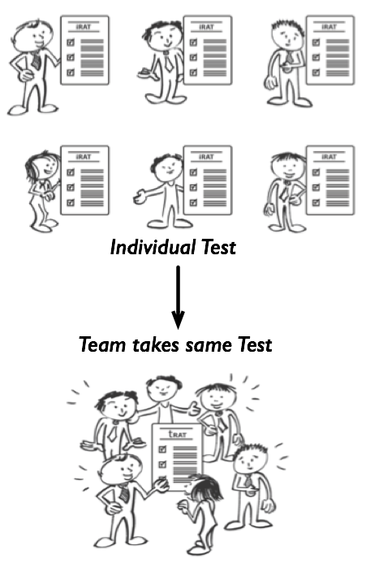
Four steps for doing TBL right:
1. Strategically form teams
Instructors use criterion to create diverse teams. Maybe each team needs someone with a previous degree, or work experience, or someone good at stats. The idea is to spread the assets you think all teams will need to be successful. TBL needs large teams (5-7 students), in comparison to other forms of cooperative and collaborative learning. The teams need to be long-term, so team cohesion can build.

2. Get students to come prepared

The Readiness Assurance Process (RAP) is used to motivate students to come to class prepared and then turns that preparation into true readiness to begin problem solving.

- Assigned Preparation: Students review preparatory materials before class.
- Individual Test: Students complete a 10-20 in-class multiple-choice question test known as the Individual Readiness Assurance Test (iRAT).
- Team Test: Students retake the same test in their teams using IF-AT cards (scratch cards). This is known as the Team Readiness Assurance Test (tRAT).
- Written Team Appeal: Following the tRAT the teams can appeal any question they got wrong by completing an Appeals form. The appeal must have (a) a clear statement of argument, and (b) evidence cited from the preparation materials. The instructor collects the completed forms and considers them after class.
- Short Mini-lecture: To conclude the Readiness Assurance Process, the instructor delivers a short facilitated discussion or mini-lecture to clarify only on the concepts that remain problematic for the students.

3. Help students learn how apply course concepts
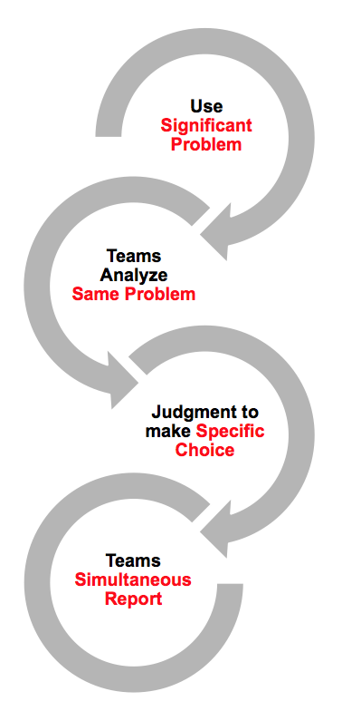
The 4S framework is used to structure TBL classroom activities. The 4S’s stand for Significant Problems, Same Problem, Specific Choice, and Simultaneous Report. The bulk of class time is spent having student teams solve, report, and discuss solutions to significant problems. The quality of the problem ultimately controls the effectiveness, energy, and learning outcomes of the activity.

The structure of TBL activities gives individuals and their team opportunity to analyze scenarios, make judgments/decisions, and publicly commit to a decision. This public report of a team’s decision creates an intense reporting conversation where students get specific and timely feedback on the quality of their thinking and their process for arriving at their decision.

Example 4S Ideas
Historian reconciles conflicting sources.
Doctor decides the best course of action.
Businessperson picks the best location for a business.
Writer identifies the most powerful passage or best example.

4. Hold students accountable and provide frequent feedback

Students must be accountable. There is individual accountability from the iRAT, but what is most motivating is the accountability to teammates during the tRAT’s and Application Activities. The combination of peer pressure to be prepared and contribute and peer evaluation with “enough teeth” to motivate students.

Students must get immediate and specific feedback to guide their learning. When you use the 4S problem-solving framework to build activities that require students to make complex decisions and publically report them, it leads to intense give and take reporting conversations – “Why did you choose that?” “What was the most important piece of evidence?” “What led you to that conclusion?” It is these conversations that give students and teams rich, immediate, and specific feedback on the quality of their thinking/decision-making.

