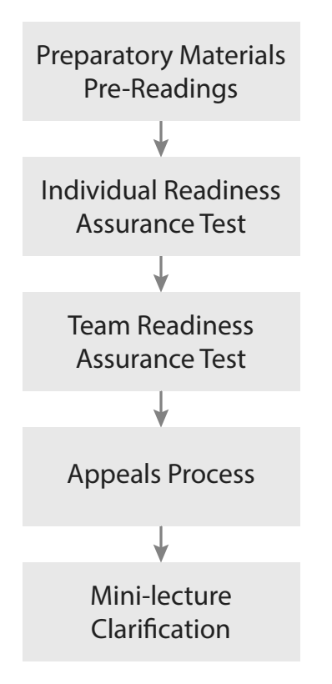
Where is the Power in the RAP?
As you have learned, TBL’s Readiness Assurance Process is a carefully scripted five stage process. There are major synergies between the stages.
Specific Concrete Situation
You have been using TBL for 3 years in your 2nd year Sociology class. Each year there are approximately 70 students. It is mid-October, and you are just starting the 3rd module of your course, so students have completed two RAP cycles. The class average for the first two RAP cycles was 62% for the iRAT’s and 96% for the tRAT’s
There was some student grumbling after the 1st RAP about not knowing what to read and focus on, so you spent some class time working with students to improve their reading strategies. It seemed to work. Grades went up, students seemed happier, and students seemed better prepared for the 2nd RAP.
You have just completed today’s RAP cycle. It has been a typical RAP class. A 12 question iRAT, followed, by the tRAT (using same test and IF-AT cards), followed by the Appeals process (every team appealed at least one question), and finally a short 8 minute mini-lecture on a couple of troublesome concepts that remained.
Try to imagine the amount of learning that took place at each stage of today’s RAP cycle.
Step 1: Complete Situational Analysis
Given 100 points to distribute across the RAP stages (nominally 20 points per stage). Assign more points to stages that are in your opinion is more powerful educationally. Write your team consensus scores for each stage on the provide flipchart page (one per team).
Step 2: Prepare to Report
Reporting will have each team simultaneously post their single flipchart page. This will be followed by a gallery walk and discussion.
Be prepared to defend your points distribution.
Report on Flipchart page

Is it a 4S activity?
Step 1: Watch Video - https://youtu.be/F0AjCC0Rpgc
Watch the video clip and decide to what extent this is a good example of TBL.
Specifically, analyzing which of the 4S components are present and how well they are implemented?
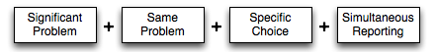
Step Two: Complete individual analysis
Determine for yourself the extent this is an example of TBL on a scale of 0-10 (10 being a perfect example of TBL and O no aspects of TBL were seen).
Be prepared to say WHY
Step Three: Pool analysis, achieve consensus, prepare to report
Compare your scores with your teammates, discuss, and find consensus.
Write your team’s score on one of the small whiteboards and prepare to hold it up when you are prompted.
Be prepared to say WHY
Writing a good 4S question prompt
You have become the TBL “expert” at your school and have been asked to help your faculty colleague’s in their shift to TBL.
You are working with an instructor in a first year English instructor. They are creating an assignment about the use of the active and passive voice. You are coaching them to create an assignment that is both cognitively challenging and will create a rich reporting discussion.
They have come up with a series of possible assignment prompt wordings and now want your guidance in selecting the best. Which of the following wordings would be the best for a TBL 4S activity?
A. List the mistakes writers frequently make that detract from their efforts to write in an active voice.
B. Read the following passage and identify clear examples of active voice and passive voice.
C. Read the following passage and identify the sentence in which the passive voice is used most appropriately.

