Maps and Push Pins

You are consulting to a new business owner that wants to open a dry cleaning store in Norman, Oklahoma. Where would you recommend they locate a new dry cleaning business (and why)?
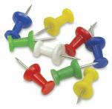
- Specific Choice - Push Pin in map

Voting Cards

You are an English teacher. You are working with your students to develop their understanding of the Active and Passive voice. You are trying to develop their next assignment. Which assignment wording would best promote higher level thinking and a rich reporting discussion?
- List the mistakes that writer frequently make that detract from their efforts to write in an active ‘voice’
- Read the following passage and identify a sentence that is a clear example of: a) active, and b) passive ‘voice’.
- Read the following passage and identify the sentence in which the passive ‘voice’ is used most appropriately.
- Specific Choice - Show Voting Card
Whiteboards

Given the following investment portfolio, investor profile, and market conditions which stock would you sell first and when?
OR
A patient presents at the ER with the following symptoms. What would be your first course of action? What test would you order first?
- Specific Choice - Write decision on whiteboard
Gallery Walks

Sometimes when problems require a bit more writing you can do gallery walks. Student teams present their plans on flipchart paper. This can be effective since it requires teams to distill their decision down to ideas that can be captured on a flipchart and the public reporting help teams take the task seriously.

Hot Seat Reporting

Use numbered balls to randomly select student teams to report. Teams can display their completed worksheet with analysis using a document camera and walk their classmates through their work. After a few teams there is often convergence in presented rationales and decisions and an instructor opportunity to provide closure.

Scissors and Glue Sticks

Student bring individually prepared documents and are given class time to distill documents down to a team version. This gets students reading each other work and working with grading criteria to identify valuable parts of each document for inclusion in team submission.

Excel Charts

Given this airfoil shape. What would be the optimal placement for a Pitot tube (airspeed measurement device)? Provide an x/y coordinate.
- Specific Choice - x/y coordinate on EXCEL chart
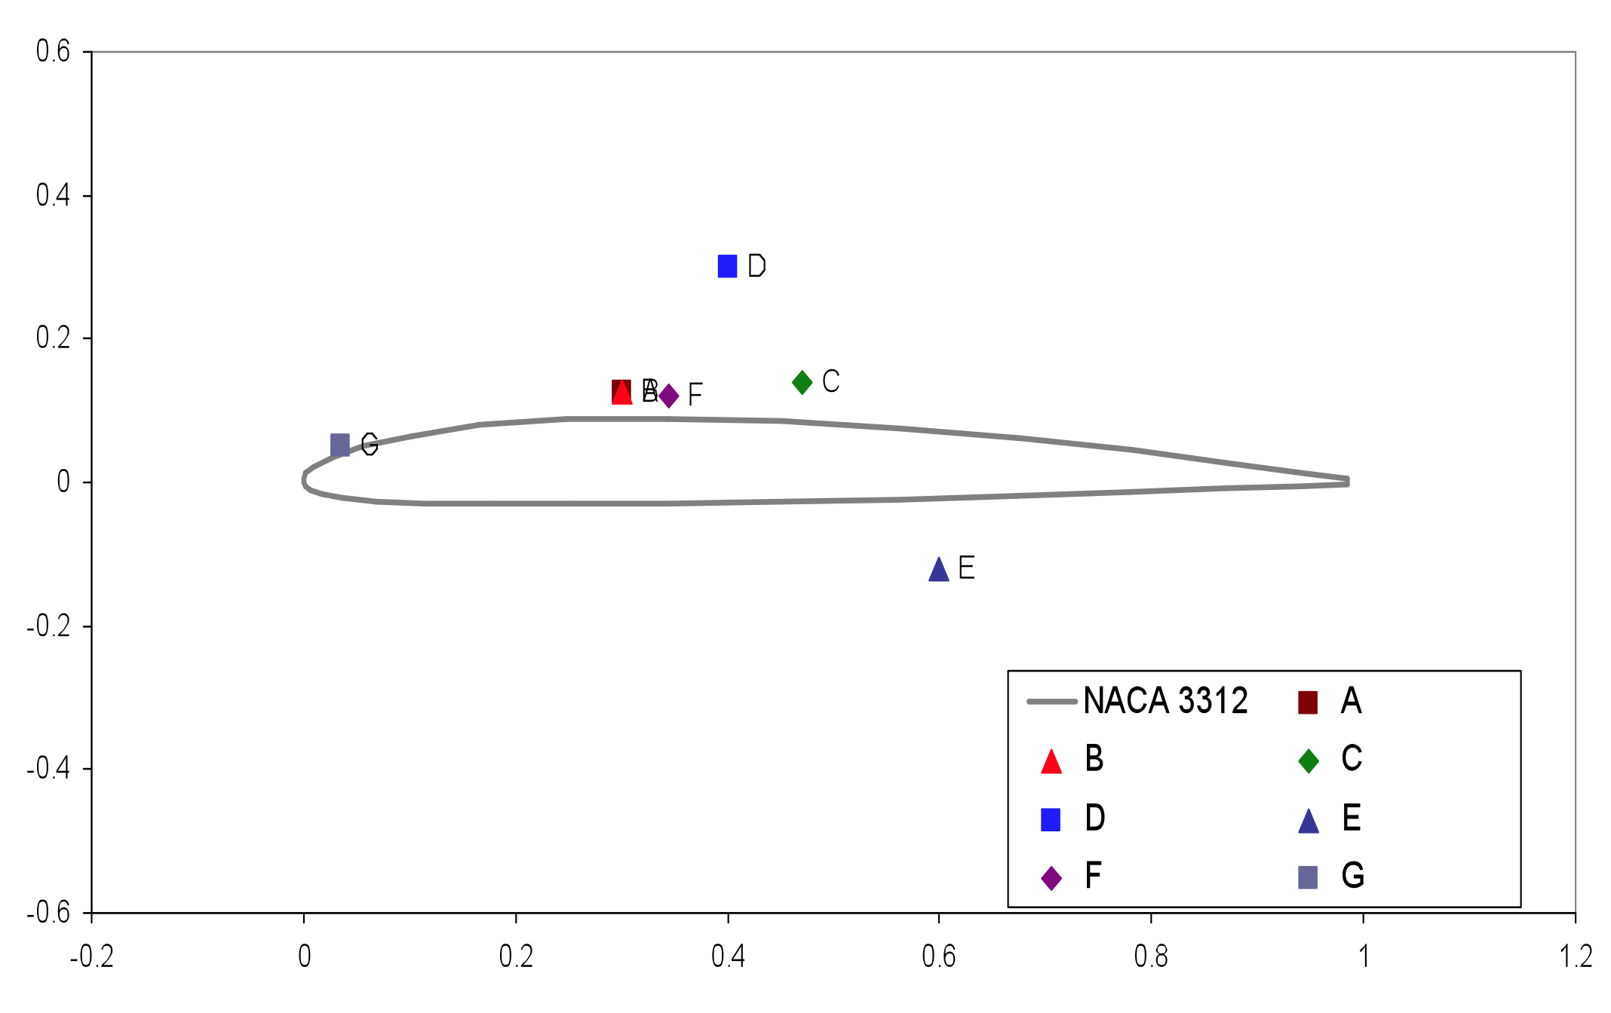

Stacked Overheads

Given the following x-ray. Identify the most clinically problematic area. Circle the area with a colored pen and be prepared with a rationale to defend your analysis.
OR
You are a consulting geophysicist to a mining company that is looking for new ore deposits on their property. Given these geophysics results, what area of the log is of most interest and what trends are most significant? Indentify the most important area and trend.
- Specific Choice - Circle area on transparency, instructor stacks transparencies for simultaneous report

