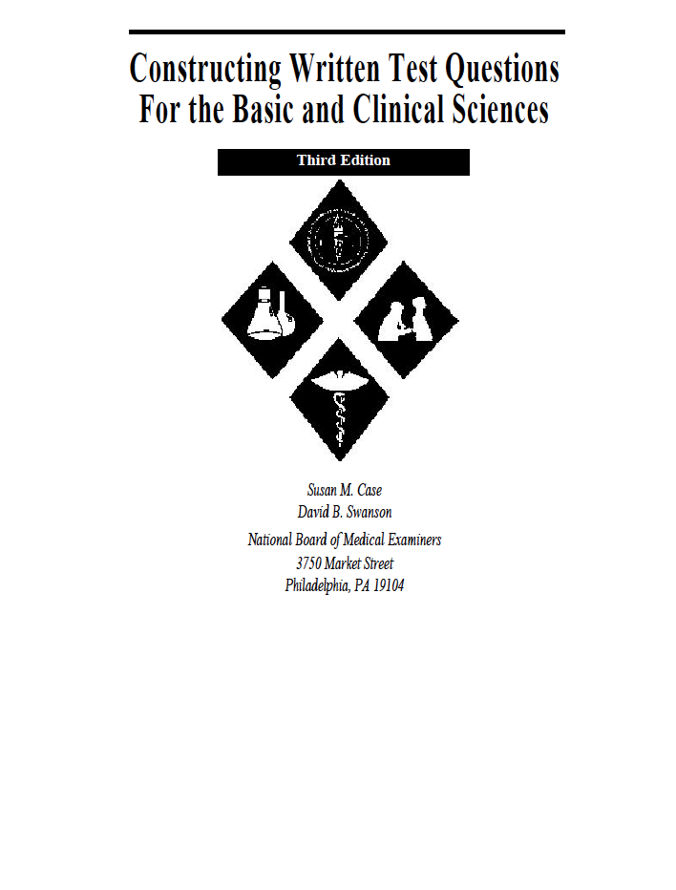
You can download a free copy of the National Medical Board Examiners excellent manual
“Constructing Written Test Questions for the Basic and Clinical Sciences”

http://www.nbme.org/publications/item-writing-manual.html

Google “nmbe mcq manual”

