Customs and Immigration Information

What I am going to US to do?

Conduct an invited one-day Team-Based Learning Workshop

Are you being paid?

YES

Who has invited me?

Where I am staying?

How long will I be in US?

My contact information

James Edward Sibley
106-2575 West 4th Ave.
Vancouver, British Columbia
Canada
V6K 1P5

jim.sibley@gmail.com

(home) 604-564-1043
(office) 604-822-9241

Why would they invite me, in particular? (Bio)

Jim Sibley is Director of the Centre for Instructional Support at the Faculty of Applied Science at University of British Columbia (UBC) in Vancouver, Canada. As a faculty developer, he has led a 12-year implementation of Team-Based Learning in Engineering and Nursing at UBC with a focus on large classroom facilitation. Jim has over 34 years experience in faculty support and training, and facilitation at UBC.
Jim serves on the editorial board of the Journal on Excellence in College Teaching (term 2014-2017). Jim is an active member of the Team-Based Learning Collaborative and has served on its board and many of its sub-committees. He has mentored colleagues in the Team-Based Learning Collaborative’s Train the Trainer mentorship program. He is co-author of the new book Getting Started with Team-Based Learning that was published by Stylus in July 2014. He is an international TBL consultant, having worked at schools in Australia, Korea, Pakistan, Lebanon, United States, and Canada to develop TBL programs.

Current Position:
Director
Centre for Instructional Support
Faculty of Applied Science
University of British Columbia
1214-6250 Applied Science Lane
Vancouver, British Columbia
Canada
V6T 1Z4

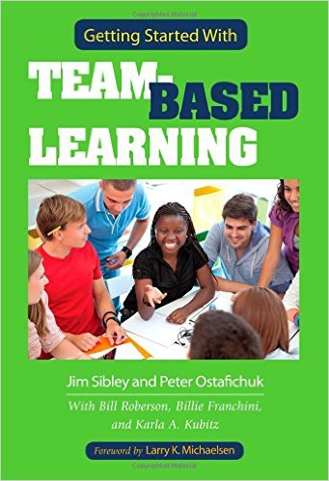
My Book
This book is written for anyone who interested in learning more about Team-Based Learning (TBL). Whether you are searching for a better way to help your student learn or want to reinvigorate your teaching, TBL can be the answer. This book will get you started with TBL right.
The book is written by five authors who use TBL in their teaching and who are internationally recognized as mentors and trainers of faculty making the switch to TBL. The book also presents the tips and insights from interviews with 46 faculty members from around the world who have adopted the TBL teaching method.
TBL is a uniquely powerful form of small group learning. It harnesses the power of teams and social learning with accountability structures and instructional sequences. This book provides the guidance, from first principles to more advanced examples of practice, together with concrete advice, suggestions, and tips to help you succeed in the TBL classroom. This book will help you understand what TBL is and why it is so powerful. You will find what you need to plan, build, implement, and use TBL effectively. This book will appeal to both the novice and the expert TBL teacher.
https://styluspub.presswarehouse.com/Books/SearchResults.aspx?str=getting+started+with+

My Website (learntbl.ca)

