Discussion Planning using ORID model

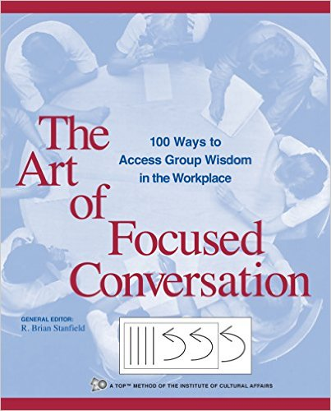
A focused conversation framework can be used to structure the body of any discussion. There are a number of focused conversation frameworks that allow you to pre-plan aspects of the conversation to ensure the examination of the issues is systematic and comprehensive. My favourite discussion framework is the ORID framework from Stanfield’s excellent book The Art of Focused Conversation. ORID is an acronym, which stands for Objective, Reflective, Interpretive, and Decisional. These four are progressive stages in a systematic, methodical analysis discussion. In the first stage, Objective, you establish the facts, agree on the data, and established a shared view of how we perceive the “facts” of the issue. This helps get everyone on the same page. In the second stage, Reflective, we get peoples personal reactions to the issue out in the open. Beliefs, attitudes, and personal internal responses are important to make visible at this stage. In the next stage, Interpretive, we search for meaning and try to establish what is significant and what is not. Values play an important role in establishing what each of us find significant. In the last stage, Decisional, we are seeking resolution, calls to actions, and considering future implications. We are trying to bring the conversation to a powerful close. There are different prompts for different ORID stages.

Objective
What is this?
What do you see?
What happened?
What are the main ideas/points?
What words or phrases really stand out?
What recommendations were made?
Where would you like to have more information?
What information would you like to verify?
What are the different aspects of the problem?
What assumptions are being made?

Reflective
What do you agree with?
Where did you most identify with reading? Where did you feel convinced? What ideas intrigued you? Where were you surprised?
What do you disagree with? What part of this makes you mad? Where did you feel uneasy? What should concern us? What do you acknowledge as necessary, but don’t like?
Where did you reconsider a previous belief?
Have you dealt with this kind of situation in the past?

Interpretive
What is the real intent of…? What was this really about?
What should we learn from this? What is the insight? What did you learn that you didn’t know before? What would be the advantages/disadvantages?
What is the significance of this? What came through to you as very important?
What difference will this make? What will this accomplish?
What effects will these changes have? Who else will be affected?
How could we use it? What will we need to do differently?

Decisional
What would you recommend? What decision is called for?
What would be the first step? What are the first 3 steps?
What should we do now? How should we proceed?

Two facilitation steps to foster Critical Thought?

Step One - General

When facilitating a discussion there are some general strategies that you can use to deepen the discussion and try to ensure a more comprehensive examination of the issues.

Listening
Letting participants know they are being “heard”

Repeating and Clarifying
Probing and Elaborating
Paraphrasing
Summarizing
Gesturing and Non-verbal
Recording

Processing
Helping participants learn how to step back from their ideas and “think” about them

Transitioning and Linking
Challenging
Acknowledging
Evaluating
Informing
Interrupting
Gesturing and Non-verbal

Step Two – Critical Thinking

Part of your job as a discussion facilitator it to help you students develop a critical argument, not just tell you why they picked a particular choice. You need to help them more thoroughly examine their thinking process that led to their decision/position. The facilitation questions that you use to gently guide students can be generated from the common attributes of critical thinking.

Relevant Information - Identifying and evaluating quality of information
Missing Information - Identifying any missing information
Assumptions - Identifying underlying assumptions (own and others)
Necessary Inferences - Identifying when inferences need to be made with incomplete information
Multiple Perspectives - Recognizing complexity and using different perspectives to analyze problem
Contextual Effects - recognizing influence of context – limits of applicability

Putting it all together - Critical Thinking + ORID (example)

The ORID framework questions can be used to structure this kind of discussion. Here is an example built around the ORID framework:

Objective
- What are the facts?
- What are the main ideas/points?
- Where would you like to have more information?
- What information would you like to verify?
- What assumptions are being made?

Reflective
- Would you be comfortable making this decision with limited information?
- What information would you like to have?
- Where did you feel convinced?
- What should concern us? What do you acknowledge as necessary, but don’t like?
- Have you dealt you seen this kind of situation in the past?

Interpretive
- Is there another important perspective we aren’t considering?
- What would happen if we changed…..?
- Can we apply this kind of thinking to this different situation?
- What effects will these changes have? Who else will be affected?
- What should we learn from this?

Decisional
- What should be done?
- What was your first choice?
- What was your second choice?
- What are the first 3 steps?
- Was there disagreement inside your team about the best choice?

