Design a Great Activity

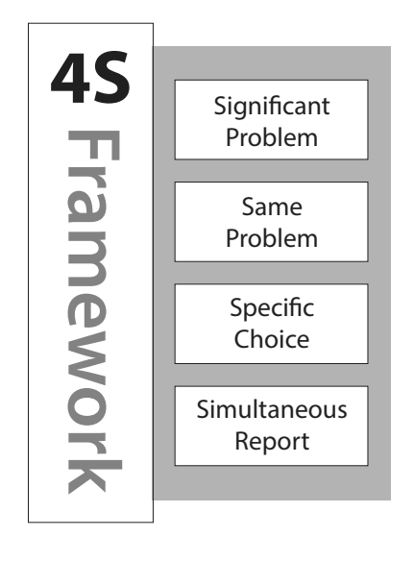
Step 1: Construct a basic Learning Outcome

At a very simple level – writing a learning outcome can be as simple as attaching a Bloom’s verb to a piece of content. Consider: I want students to know about flood return periods, I could simply add the Bloom’s verb “define” to flood return period.
Define + Flood Return Period = Learning Outcome
This is a typical content focused, low Bloom’s level learning outcome.

Step 2: Raise Bloom’s level of your Learning Outcome

Explain Flood Return Period

In this step, we raise the Bloom’s level by changing the verb used. In this example, the change from “define” to “explain” has moved the learning outcome from the lowest Bloom’s level – Remembering - to the slightly higher Understanding level.

Step 3: Make Learning Outcome about Action

Demonstrate understanding of Flood Return Period

In this step, we change the learning outcome to be more about concrete action rather than abstract understanding. Students should be given the opportunity to use what they know, extend their knowledge, and finally show us they know (truly achieve learning outcome).

For ideas, we want to think about our discipline and the kinds of questions experts are routinely asked to make, the kinds of data/reports/files they work with, the inferences, judgments, and especially decisions they are required to make. These often are the source of inspiration to make a great 4S task.

Although the action verb “demonstrate” is an improvement, the learning outcome doesn’t provide any information on how the students might “demonstrate” this understanding. Combining the identified disciplinary action with the desired learning outcome, it is time to create a 4S question prompt.

Step 4: Change Learning Outcome into a question prompt with a superlative
Which of the following statements best demonstrates an understanding of Flood Return Period?

You want to make sure the question prompt you create contains a superlative (Best, First, Worst, etc.). This superlative is the catalyst for focused student inquiry – requiring them to analyze, discriminate, and finally report a reasonable choice or course of action related to this specific concrete situation.

- Which of the following would be the - Best, Worst, First, Most effective, etc. – thing to do or reasonably conclude or to interpret, etc. - in this specific, concrete situation?

It is worth remembering we want the question prompt to constrain the decision space, so the reporting analysis and discussion is more focused on the specific issues we have identified as important for student learning. Think about the difference in the reporting conversation for “what would be the best thing to do in this situation?” versus the more diffuse “what would you do it this situation?”

Step 5: Use template to create other 4S question parts

Once we have a question prompt in mind, we can start completing the other pieces of a complete 4S question.

It is worth noting that the specific detail you add to the scenario can guide students to analyze the problem a certain way using the provided detail or pointers to data sets. Similarly, the mix of different course of action/decisions possibilities can have students naturally examine the situation from a specific set of perspectives that you have intentionally pointed them towards.

It is worth remembering that the possible decisions can look like simple multiple-choice options, but they can be so much more. What is important is that the choices are specific – which plan would you choose? Each plan could be several long documents or which datasets best support this conclusion? The data set could be big, have gaps, be slightly different in their presentation – what is important is a specific choice needs to be made that is simple to report.

