Using Constrained Choice to Intensify Student Discussion

Great activities inspire curiosity, engage learners, and foster powerful discussions. Our instincts might lead us astray here. We might think the best way to foster a full exploration of a topic is to start discussions with a wide-ranging, open-ended question that opens a wide range of avenues of inquiry. Our hope is the collective, focused wisdom of the group will eventually emerge from the discussion. The problem is that the disciplinary novices can often take the discussion in non-productive directions and this can create real facilitation challenges for teachers.

One way to control this is to frame discussions more intentionally using specific, explicit choices, while giving students broad autonomy on how they arrive at choosing one of those specific choices.

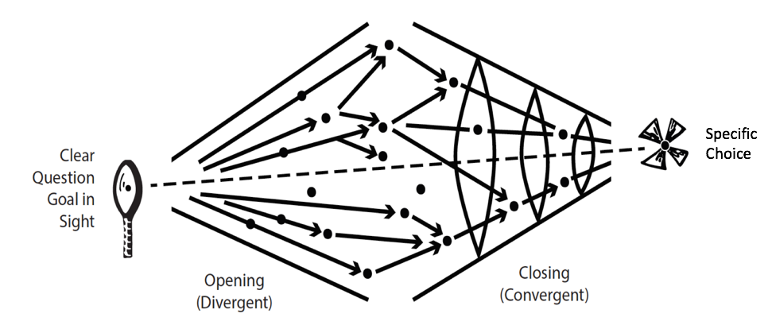
The critical design element is the combination of a specific question leading to specific choice/decision (i.e. choice of the most reasonable course of action from a list of possible courses of action). By constraining the possible choices, you can intentionally focus the analysis process and subsequent reporting conversation on certain salient concepts, issues, contextual factors, data sources, or procedures.

These kinds of constrained questions are the heart of the Team-Based Learning method. The constrained choice questions in TBL are built using what is known as the 4S model. The 4S process starts with a significant question. Every team gets asked the same question. You require teams to make a difficult specific choice (constrained choice), which then makes simultaneous reporting possible (public commitment to our choice). The good news is you can use the 4S model and process without committing to the entire TBL model.

Getting each team to commit to a specific choice/course of action that is publicly declared forces student to take their analysis seriously. The specific choice allows for the powerful simultaneous report of all teams decisions – a moment of truth. This public reveal makes student thinking visible, and is a powerful starting point for an intense give and take conversation where teams critique, challenge other teams decisions, and defend their own position and share their reasoning for arriving at their particular choice.

Build your own a Constrained Choice Problem
Consider: Disciplines are clearly defined by how those working within the discipline collect, organize, assess, and use information. (Roberson and Franchini, 2014, p. 278)

Pick a specific, concrete decision that requires judgment
- Evaluation of something (product, statement, resource, market, argument…)
- Assessment/diagnosis of something (situation, patient…)
- Prediction about something (probable consequence of an action…)
- Recommendation (how to avoid damage, bankruptcy, incarceration, disaster…)

Consider: Scenarios allow you to embed many variables that can be used to introduce multiple concepts, theories and perspectives into students’ discussion, as well as to complicate the task, if desired, through a mix of relevant factors and red herrings.” (Roberson and Franchini, 2014, p. 287)

Create a story about a situation that brings students to a decision point
  - You go into the supermarket and see 8 brands of cheese…
  - Here’s a picture of a client who just walked into your hair salon…
  - Here are three letters by applicants for director of…
  - Here’s an article on the defunding of education from newspaper x…
  - Here’s a description of the assassination of Henry IV…
  - Here are 3 paragraphs about X by 3 different authors…
  - Here’s a new product that needs testing…

Consider: The function of the collective decision task, therefore, is to place a restrictive frame around the team’s action. This restriction forces the team to evaluate, integrate and, if needed, respectfully discount a team member’s inputs enroute to a judgment and a focused decision.
(Roberson and Franchini, 2014, p. 288)

Write a prompt as a DECISION or CHOICE needed in response to a situation - that naturally elicit why this and not that?
  - Which of the options presented is best/worst?
  - What would you do first/last?
  - Which of these items will be most/least effective?
  - What will be the most likely outcome/consequence of…?
  - How would you rank these?
  - What score would you give this?

- Rank these proposals for their effectiveness at presenting a vision consistent with the project plan. Why did you rank them that way?
- Decide which of these equations will be most effective in calculating accurately the liquid capacity of this strangely dented milk carton? Why?
- Decide which of these accounts of what occurred at Wounded Knee is the most credible? Why?
- Based on this (given) paragraph by Tolstoy, what will most likely be the thematic function of this new character in the story? Why?
- A patient comes into emergency with the following symptoms...
    - What is the first thing you would do? And why?
    - What is the first test you would order? And why?
    - What would be the worst thing to do? And why?
- Given 3 possible programs to end homelessness in your city, select the program that is the best and will likely be most strongly supported by local agencies and Civic leaders? (Michaelsen and Sweet)
- What is the most relevant theory that explains the behaviour in the video? (Kubitz and Lightner)
- Which of the following best describes the opportunity cost of coming to class today? (Espey)
- Which of the following should the University do to best improve the quality of Undergraduate education? (Mahler)
- Which sampling scenario would best address this research project? (Mahler)
- Given three valid historical interpretations of the progressive Movement, discern which best describes the Progressives revealed in our manifesto? (Restad)
- In Clarence Page’s op-ed piece “The Problem with Trashing Liberty”’ where does the responsibility for a safe a civil society lie? Which of the following three philosophers (X, Y, and Z) does Clarence Page most agree with on these fronts? (Roberson and Reimers)
- What of the following passages in the Bhagavad Gita best illustrates reflection about the nature of Krishna’s divinity? (Dubois)
- Rank how useful each source is for understanding the fears of the Cold War era. (Restad)
- Which (specific) teacher should be nominated for a teaching award? (Croyle and Alfaro)
- Which indicator (from a list of 5 plausible alternatives) is most critical to making a correct diagnosis in this case? (Michaelsen and Sweet)
- If a massively overweight vehicle drives slowly onto this bridge structure, which structural component would likely fail first?
- You are making a home assessment, which of the following safety hazards would be of greatest concern? (Clark)
- After assessing Mrs. Randall’s dining room what would be your first recommendation to protect her from falls? (Clark)
- What line on this tax form would pose the greatest finical risk due to an IRS audit? (Michaelsen and Sweet)
- Given a set of real data, which of the following advertising claims is least (or most) supportable? (Michaelsen and Sweet)
- You are consulting for a new business owner who wants to open a dry-cleaning store in Norman, Oklahoma. Which location would you recommend? (Michaelsen)
- Based on these market trends on which date would you sell stock X?
- Based on these market trends which of these 3 stocks would you recommend selling first (X, Y or Z)?
- Imagine Jean Paul Sartre goes to coffee with Plato. They get in a heated discussion about their contrasting views on X. Based on what you know about each of these thinkers and their ideas about X, which of the following statements best summarizes their disagreement?

- Which of the following passage (from Hamlet, The Brothers Karamazov, Sons & Lovers, God of Small things, Mrs Dalloway) best illustrates the thematic idea of jealousy for one’s father, using Freud’s interpretations of the Oedipus complex?

- You have been asked to design a bridge for the local salt water marina. Which building material would it be best to use (could easily be cheapest, easiest, worst) to construct the bridge (wood, concrete, or steel)?

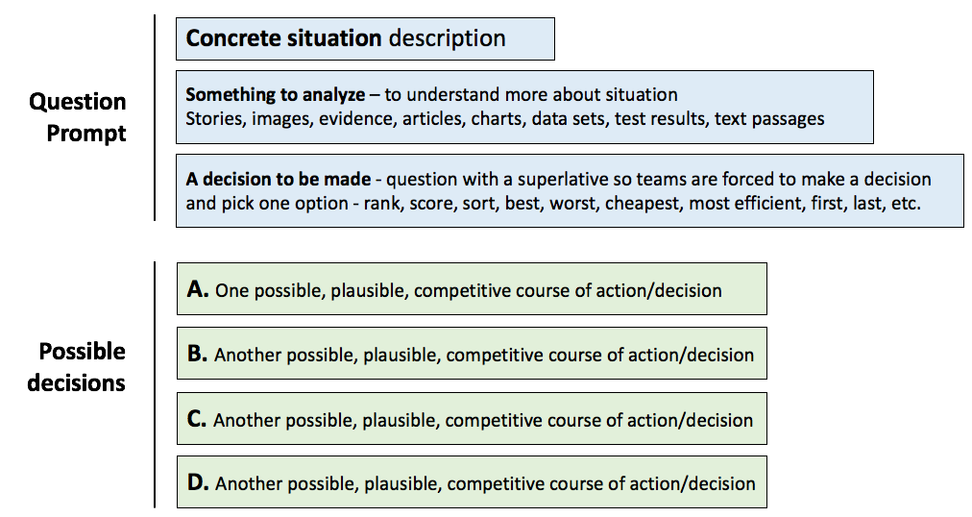

Checking your Work

- Specific question pertains to specific situation (not abstractions)
- Requires a specific, concrete decision to force careful analysis, discrimination, and commitment.
- Decision analysis is complex - what data, evidence or reasoning will students use?
- Description of situation has selected, specific details to focus student analysis
- Question prompt contains a superlative to force discrimination (best, worst, first, rank)

This handout is a compilation of ideas and materials created by Bill Roberson and Jim Sibley
Quotes from Effective task design for the TBL classroom - Bill Roberson & Billie Franchini (2014)

