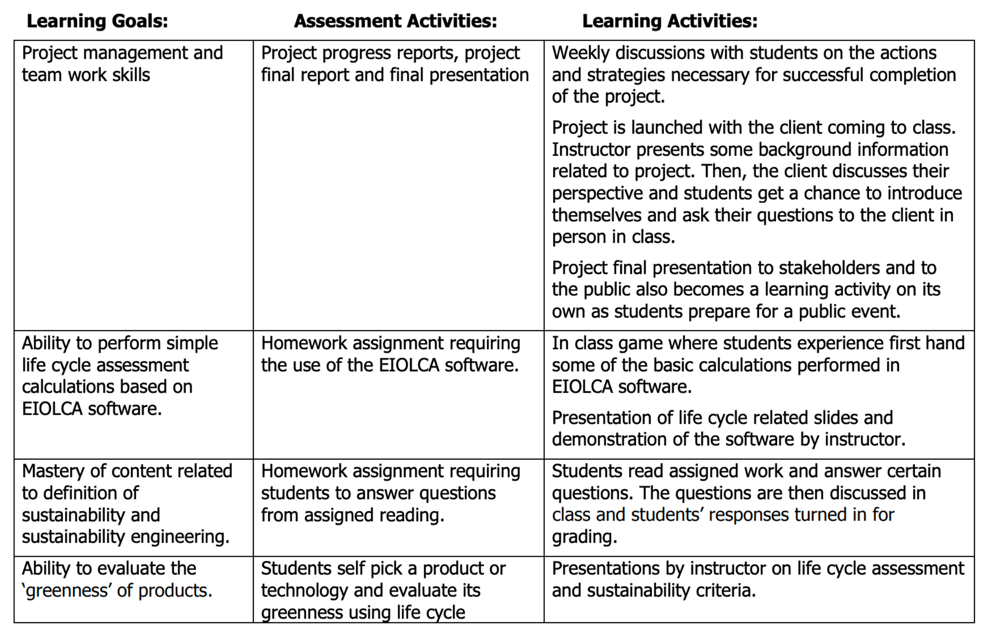
Remembering | Understanding | Applying | Analyzing | Evaluating | Creating
define  duplicate  list  memorize  recall  state  name | classify  describe  discuss  explain  identify  locate  recognize  select  translate | execute  implement  solve  use  apply  demonstrate  interpret  operate  illustrate  dramatize  practice | differentiate  organize  relate  compare  contrast  examine  experiment  calculate  estimate  measure | evaluate  appraise  judge  criticize  support  weigh | design  assemble  construct  propose  compose  plan  create  formulate  investigate  manage
